New PhotoMOS® app:

Everything you need to know – and the one relay you need to find.

Panasonic Industry launches a mobile app to offer developers easy and valuable orientation within a range of more than 400 available types of photo-coupled MOSFET relays – for any kind of application.

Munich, January 2022

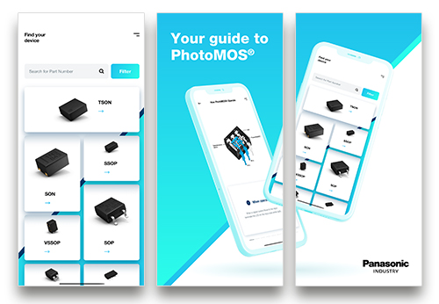 *I'm sure there is what I need,* *but how can I find it?* - this roughly summarizes a common headache most product developers and designers occasionally suffer from - especially when it comes to finding the one component that exactly matches a new application’s requirements in each and every criterion.

In the field of photo-coupled MOSFET relays – undoubtedly the proven and modern alternative to their electromechanical predecessors – there is some valuable orientation in sight as Panasonic Industry has just launched its PhotoMOS® app for free download:

Finding the most suitable types among the 400 variants is now very easy With just a few taps, designers can save their results as favorites, directly download the datasheet, or immediately request some samples from Panasonic Industry.

For anyone curious to learn more about the technology, the integrated MOSpedia offers answers on specs, features and benefits of PhotoMOS® relays – and more than a dozen application notes will provide answers to common design-in questions.

“Nowadays, being a committed enabler for the industry does not only mean developing market-leading and reliable technologies, but also making them accessible and sharing relevant knowledge in the easiest way possible”, explains Sebastian Holzinger from Panasonic Industry. “Where would that work out quicker and easier than on the mobile devices we have with us every day?”

Get a first impression of the app [in our brief video](https://youtu.be/EnGILI7wszU) – and download the new [PhotoMOS® App here](https://industry.panasonic.eu/products/components/relays/photomos-relays/photomos-app).

**About Panasonic**

Panasonic Corporation is a global leader developing innovative technologies and solutions for wide-ranging applications in the consumer electronics, housing, automotive, and B2B sectors. The company, which celebrated its 100th anniversary in 2018, operates 522 subsidiaries and 69 associated companies worldwide and reported consolidated net sales of Euro 54.02 billion (6,698.8 billion yen) for the year ended March 31, 2021. Committed to pursuing new value through collaborative innovation, the company uses its technologies to create a better life and a better world for customers. Learn more about Panasonic: <https://www.panasonic.com/global>

.

**About Panasonic Industry Europe**

Panasonic Industry Europe GmbH is part of the global Panasonic Group and provides automotive and industrial products and services in Europe. As a partner for the industrial sector, Panasonic researches, develops, manufactures and supplies technologies that support the slogan “A Better Life, A Better World”.

The company’s portfolio covers key electronic components, devices and modules up to complete solutions and production equipment for manufacturing lines across a broad range of industries. Panasonic Industry Europe is part of the global company Panasonic Industrial Solutions.

More about Panasonic Industry Europe: <http://industry.panasonic.eu>