**Powerful, fast drilling, lightweight: Panasonic’s new 18V cordless rotary hammer**

The new cordless rotary hammer EY1HD1 provides 2.1 Joules power with advanced dust control in a compact and lightweight body for professional use

Munich, Febuary 2023

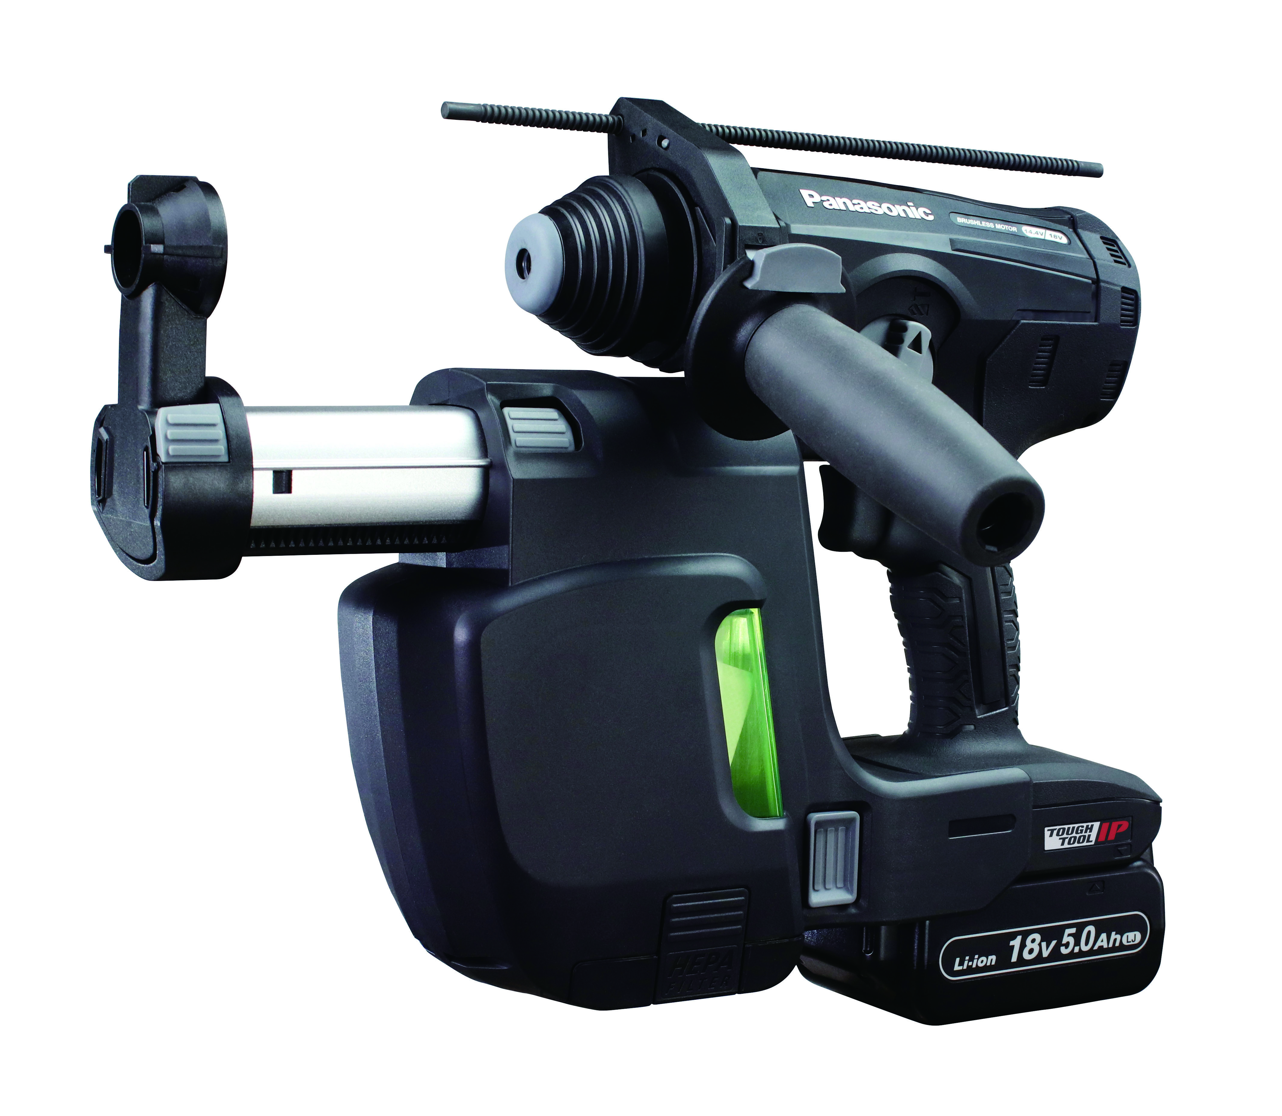Drilling holes in concrete ceilings can be exhausting. Handling a heavy tool, exposure to concrete dust, and repeatedly working overhead can compromise precision and efficiency.

The all-new cordless 18V rotary hammer EY1HD1 from Panasonic tackles this challenge:

With an actual size of less than an A3 size paper, the overall length of the EY1HD1 is only 357mm, the rotarty hammer is a compact solution for professional use. The ergonomic T-handle body design allows for precise drilling, but thanks to the reduced weight of only 3.35kg, and especially because of the central handle, the EY1HD1 provides superb balance and handling even for single-handed drilling.

**Powerful and tough**

A newly developed brushless motor enables the EY1HD1 to provide an impressive 2.1J in high mode and 1.3J in low mode. The high-density brushless motor features a full-time rotation control circuit and delivers speeds from 0 - 950min-1 (high mode) and 0 - 700min-1 (low mode). Combined with a new powerful striking mechanism with an extended stroke length, that is able to provide up to 4.200bpm in high mode and 3,100bpm in low mode, it makes drilling concrete walls and ceilings an easy job.

To ensure a long life, the mechanical parts and the rubberised switch are protected against the ingress of dust. A special gasket seals the drive unit and the hammer system. The rotary hammer also features a temperature sensor to protect the battery and motor from overheating.

**Advanced dust control**

“The compact and lightweight rotary hammer features a powerful dust collection system (DCS), that relies on an independent motor for maximum drilling and dust collection efficiency”, says Kunihiko Nedachi from Panasonic’s Power Tool department. “And with the integrated HEPA filter, the EY1HD1 protects the user and the environment from concrete dust exposure.” The DCS holds up to 200ml of dust, and a transparent window on the sides indicates the fill level.

**More convenience**

To improve working with the power tool, the EY1HD1 is equipped with LED lights, a retractable hanging hook for safe storage, e.g., on ladders, and also a quick-release button for the depth gauge.

Kunihiko Nedachi concludes: “Panasonics new cordless rotary hammer was designed for more performance and easy handling in professional environments. The increased performance of the motor and hammer system combined with comprehensive dust protection will benefit the user on a daily basis.

For further information about the cordless rotary hammer EY1HD1, [visit the world of Panasonic Power Tools.](https://www.panasonic-powertools.eu/en/construction/products/SDS-plus-Rotary-Hammer/Cordless-Rotary-Hammer-EY1HD1_p370552)

**About the Panasonic Group**

A global leader in developing innovative technologies and solutions for wide-ranging applications in the consumer electronics, housing, automotive, industry, communications, and energy sectors worldwide, the Panasonic Group switched to an operating company system on April 1, 2022 with Panasonic Holdings Corporation serving as a holding company and eight companies positioned under its umbrella. Founded in 1918, the Group is committed to enhancing the well-being of people and society and conducts its businesses based on founding principles applied to generate new value and offer sustainable solutions for today’s world. The Group reported consolidated net sales of Euro 56.40 billion (7,388.8 billion yen) for the year ended March 31, 2022. Devoted to improving the well-being of people, the Panasonic Group is united in providing superior products and services to help you Live Your Best.   
To learn more about the Panasonic Group, please visit: <https://holdings.panasonic/global/>