**More capacitance, less dissipation**Panasonic Industry introduces new ZU and ZSU series of Electrolytic Polymer Hybrid Capacitors type – each one being a remarkable evolution of the recent ZS series in specific aspects

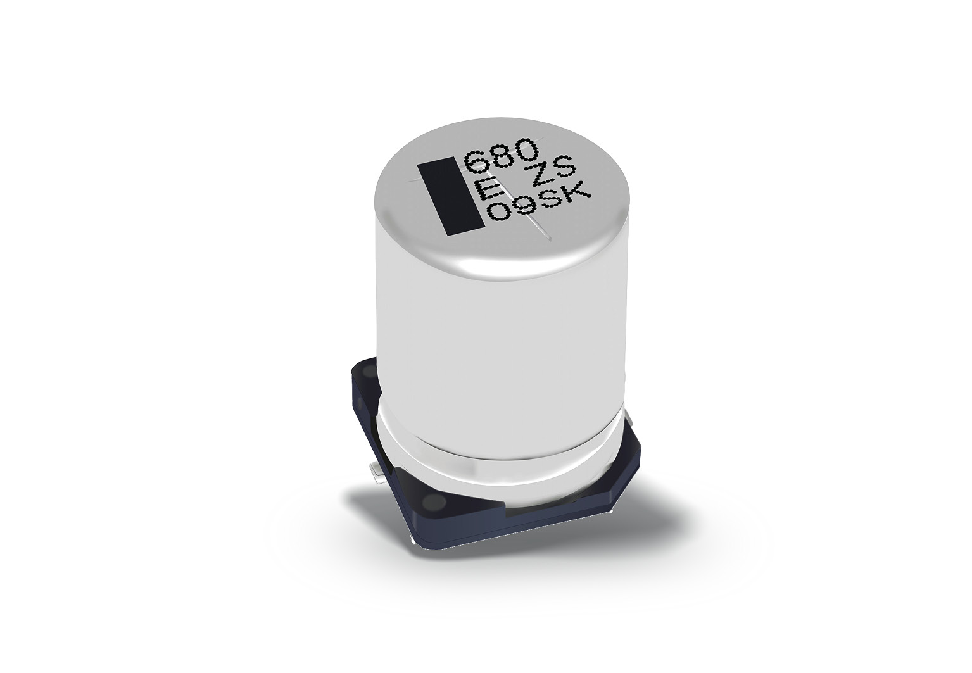Munich, FEBRUARY 2021

Reliability, efficiency, performance – this triad of automotive engineering applies in particular to the crucial components a modern car consists of.

And there is an increasing number of them, as the level of comfort, functionality and safety is increasing with every new car generation.

Acknowledging those prevalent industry trends, Panasonic Industry has developed its popular ZS series of Hybrid Capacitors with outstanding successors: When developing the **ZU** types (25~63V.DC at 8～12mΩ), the focus has been set to particularly reducing power dissipation - while the **ZSU** series (25~63V.DC, Capacitance 120～1000uF) comes with an almost unrivalled capacitance.

Yusuke Nagata from Panasonic Industry Europe summarizes: “***ZU*** *series is able to withstand ripple currents up to 53% better than its predecessor. For a diameter of 10 x 12.5mm with 25V.DC we achieve 5 Arms, for the 10 x 16.5mm equivalent 5.8 Arms. The* ***ZSU*** *series*,” continues Nagata, “*takes our capacitance specs for Hybrid Caps to an entirely new level: For a diameter of 10 x 12.5 mm with 25V.DC we achieve 680µF for the 10 x 16.5mm equivalent 1000µF*.”

Next to this, ZU series stand out with a 4,000 hours temperature endurance at 135/125℃ - and thus one of the highest tolerance currently available in the industry.

Speaking of tough conditions “under the hood” or elsewhere in industrial environments, Panasonic Industry offers the new AEC-Q200 compliant types as vibration proof versions for 6mm diameter or above, withstanding shocks of as much as 30G.

So, **ZU** series suits wherever high Ripple current is essential, for example automotive 48V applications such as Integrated Starter Generators(ISG), DC/DC, oil pumps, water pumps or fan motors.

The **ZSU** series, however, is an option when it additionally comes to applications requiring next-gen capacitance - EPS, e-compressors, ADAS applications or as well oil-pumps and the like.

“*Components serving their functional purpose immaculately under severe automotive conditions are also often the perfect choice for other fields of applications*”, points out Yusuke Nagata. And indeed: When looking at a suitable capacitor for base station power supply, industrial motor inverters or contemporary communication devices, both series definitely seem to be worth a closer look – for example in our [Product Finder](https://industry.panasonic.eu/productfinder?group=Capacitors&category=Hybrid+capacitors&lineup=Conductive+Polymer+Hybrid+Aluminum+Electrolytic+Capacitors&series=ZU+%28High+temp.+reflow%29%2CZSU+%28High+temp.+reflow%29v).

__________

**About Panasonic**

Panasonic Corporation is a global leader developing innovative technologies and solutions for wide-ranging applications in the consumer electronics, housing, automotive, and B2B sectors. The company, which celebrated its 100th anniversary in 2018, operates 528 subsidiaries and 72 associated companies worldwide and reported consolidated net sales of 61.9 billion Euro (7.49 trillion yen) for the year ended March 31, 2020. Committed to pursuing new value through collaborative innovation, the company uses its technologies to create a better life and a better world for customers.   
To learn more about Panasonic: <http://www.panasonic.com/global>

**About Panasonic Industry Europe**

Panasonic Industry Europe GmbH is part of the global Panasonic Group and provides automotive and industrial products and services in Europe. As a partner for the industrial sector, Panasonic researches, develops, manufactures and supplies technologies that support the slogan “A Better Life, A Better World”.

The company’s portfolio covers key electronic components, devices and modules up to complete solutions and production equipment for manufacturing lines across a broad range of industries. Panasonic Industry Europe is part of the global company Panasonic Industrial Solutions.

More about Panasonic Industry Europe: <http://industry.panasonic.eu>