Panasonic Industry Europe GmbH

Caroline-Herschel-Strasse 100

85521 Ottobrunn, Germany

[http://industry.panasonic.eu](http://industry.panasonic.eu/)

Press contact:

Benno Kirschenhofer

Email:

[benno.kirschenhofer@eu.panasonic.com](mailto:benno.kirschenhofer@eu.panasonic.com)

Phone: ++49-172 2814105

[http://industry.panasonic.eu](http://industry.panasonic.eu/)

**Europe’s most comprehensive relay test labs from Panasonic Industry offer technical support to customers**  
Complete infrastructure and profound know-how for customised relay performance and safety

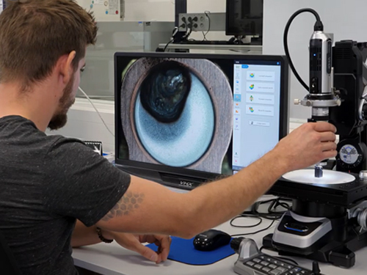Munich, NOVEMBER 2023

At its European headquarters in Ottobrunn and in Pfaffenhofen near Munich, Germany, Panasonic Industry has invested in two state-of-the-art technical laboratories to conduct rigorous tests and analysis, mainly for its broad portfolio of relays, but also for a wide field of the company’s other electromechanical products. The equipment in the labs comprises of high-voltage, stress and long-term testing stations, high-speed camera analysis devices, leakage testers, temperature simulators, a fully equipped prototyping workshop and much more. If indicated, customers can book a visit to the labs and get support from Panasonic Industry’s technical relay experts if they have special requests and requirements beyond standard applications or have other questions, e.g. about particularly harsh operating conditions for their designs.

Although Panasonic Industry’s standard relay datasheets cover more than 80% of all applications, the paper can only cover a certain range of values and parameters, which mostly refer to worst-case scenarios, for example in terms of temperature conditions. But if for example a relay isn't functioning as expected in a customer design, Panasonic Industry’s technical experts at the labs can investigate the cause. Their in-depth application analysis goes beyond testing the relay itself and provides valuable insights into any reasons for failure and helps customers resolve any design issues effectively.

Comments Bernd Prössner, Head of Relay Engineering at Panasonic Industry: “If customers for example are unsure whether the chosen relay can withstand high inrush currents, are having concerns about the potential impact of slightly higher operating temperatures in the long run or are encountering a field failure without understanding the underlying cause, our technical experts are equipped with all necessary test devices to investigate the issues in more detail – and to find individual and reliable solutions for our customers.”  
  
Discover our laboratories on our [dedicated website](https://industry.panasonic.eu/products/components/relays/technical-relay-services-and-support) and see our relay experts in motion on [YouTube](https://youtu.be/BJ7LgSfO2EA).

**About Panasonic Industry Europe GmbH**

Panasonic Industry Europe GmbH is part of the global Panasonic Industry organization, one of the five major operating companies within Panasonic Holding. Panasonic Industry Europe provides products and services for industrial customers all over Europe.   
Panasonic Industry Europe is committed to enabling customers to achieve their goals in a broad range of industrial sectors such as mobility, infrastructure, automation, medical, appliances, smart living, and security. With the know-how of devices and solution technologies, cultivated through a global mindset and over a century of tradition, Panasonic Industry collaborates closely with customers to create a sustainable future.

Panasonic Industry Europe’s broad and diverse product portfolio encompasses key electronic component sectors including electromechanical and passive components, batteries and other energy products, sensors and wireless connectivity modules, thermal management materials and custom solutions, as well as automation devices & solutions.

More about Panasonic Industry Europe: <http://industry.panasonic.eu>

**About the Panasonic Group**

Founded in 1918 and today a global leader in developing innovative technologies and solutions for wide-ranging applications in the consumer electronics, housing, automotive, industry, communications, and energy sectors worldwide, the Panasonic Group switched to an operating company system on April 1, 2022, with Panasonic Holdings Corporation serving as a holding company and eight companies positioned under its umbrella.

The Group reported consolidated net sales of Euro 59.40 billion (8,378.9 billion yen) for the year ended March 31, 2023. To learn more about the Panasonic Group, please visit: <https://holdings.panasonic/global/>