**Switching to an ever more digital PCB design**

Panasonic Industry 3D relay component libraries now available in Autodesk Fusion 360

Munich, March 2021

The seemingly endless quest in product design to simultaneously miniaturize devices while increasing functionality has rendered PCB-based engineering the silver bullet of contemporary applications efficiency.

PCB layouts are drafted, developed and realized with the help of digital parts libraries used within Autodesk Fusion 360. The purpose of these parts libraries is to help designers create electric circuits, place components on the PCB or conceive the board routing.

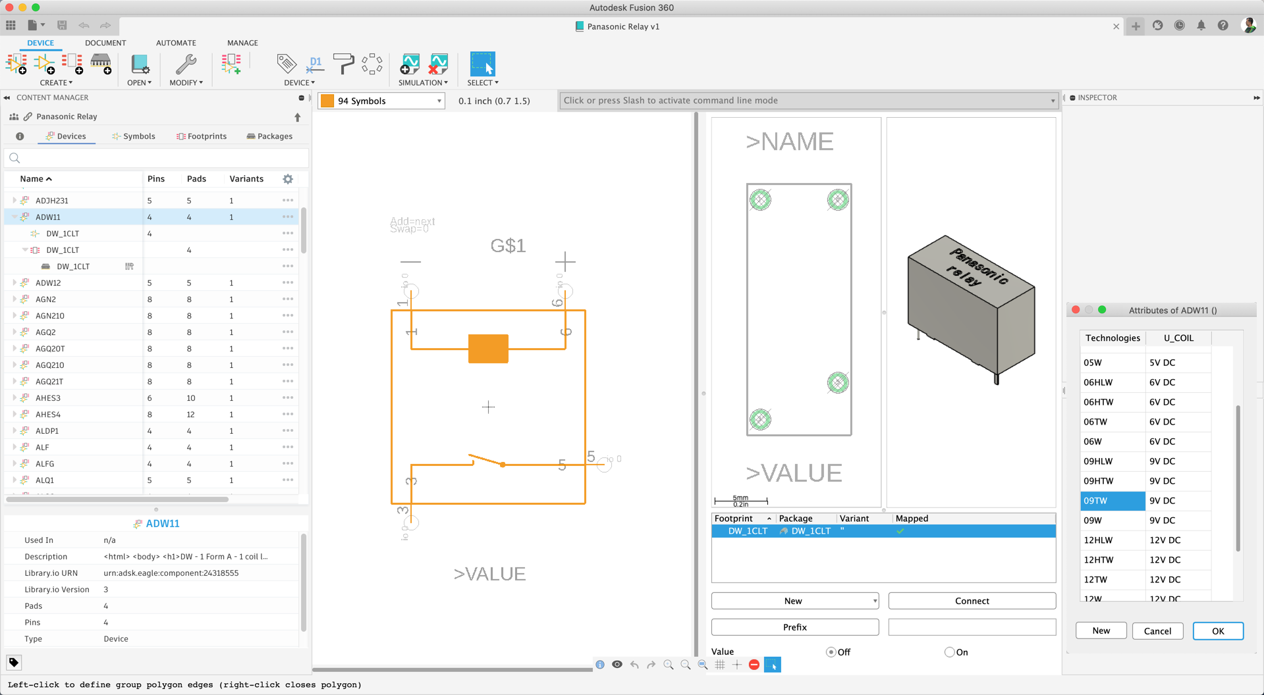

Libraries are most useful when they are complete. Accordingly, Panasonic Industry now announces availability of almost all its relay families (including PhotoMOS©) as Fusion 360 parts libraries. Most components are contained as 2D, and some as 3D data. The range of details contained in the digital models of relays includes core specifications such as switching current, switching voltage, contact arrangement, and different sizes. Having in mind that relays do not have a standard layout, the libraries will provide designers an extraordinary benefit by helping identify the best choice for electronic circuits.

Clever and convenient: When working within a library, designers can easily access directly linked data sheets with just one click or evaluate suggested alternative products and versions at a glance.

The full range of electromechanical and PhotoMOS© relays from Panasonic Industry has recently been implemented as a default library for Fusion 360 and is likely to be extended in the near future, as Bernd Proessner from Panasonic Industry points out:

“We are happy having made this crucial step towards the digital twinning of our renowned components now – and hope to be able to realize this also with our thermal component models.”

Having Panasonic Industry’s relay family available for convenient digital PCB layout has again made bringing ideas to life a bit easier.

Learn more:

<https://www.autodesk.com/products/eagle/overview>

__________

**About Panasonic**

Panasonic Corporation is a global leader developing innovative technologies and solutions for wide-ranging applications in the consumer electronics, housing, automotive, and B2B sectors. The company, which celebrated its 100th anniversary in 2018, operates 528 subsidiaries and 72 associated companies worldwide and reported consolidated net sales of 61.9 billion Euro (7.49 trillion yen) for the year ended March 31, 2020. Committed to pursuing new value through collaborative innovation, the company uses its technologies to create a better life and a better world for customers.   
To learn more about Panasonic: <http://www.panasonic.com/global>

**About Panasonic Industry Europe**

Panasonic Industry Europe GmbH is part of the global Panasonic Group and provides automotive and industrial products and services in Europe. As a partner for the industrial sector, Panasonic researches, develops, manufactures and supplies technologies that support the slogan “A Better Life, A Better World”.

The company’s portfolio covers key electronic components, devices and modules up to complete solutions and production equipment for manufacturing lines across a broad range of industries. Panasonic Industry Europe is part of the global company Panasonic Industrial Solutions.

More about Panasonic Industry Europe: <http://industry.panasonic.eu>