**A proven range of motion detection: Panasonic Industry’s inertial sensor in vehicle engineering**

Panasonic Industry’s 6DoF inertial sensor series delivers precise information about the state and motion of a vehicle or machinery - and is already relied on in a wide field of motion applications

Munich, December 2022

It’s has become an essential prerequisite in times of the ongoing “electrification of everything”: Cars, motorbikes, autonomous buses, construction machines and many other will have to feature an increasing number of safety and comfort driver aids. Comprehensive sensing is crucial to support many purposes like motion detection, positioning, sensor fusion, inclination detection – you name it.

For these purposes, Panasonic Industry Europe developed - and continuously evolves - a 6-axis inertial sensor series that provides installation freedom, additional functionalities to onboard systems with this one-chip-solution, and – being ASIL-B(D)-compliant – a high level of functional safety.

**The benefits – in a nutshell**

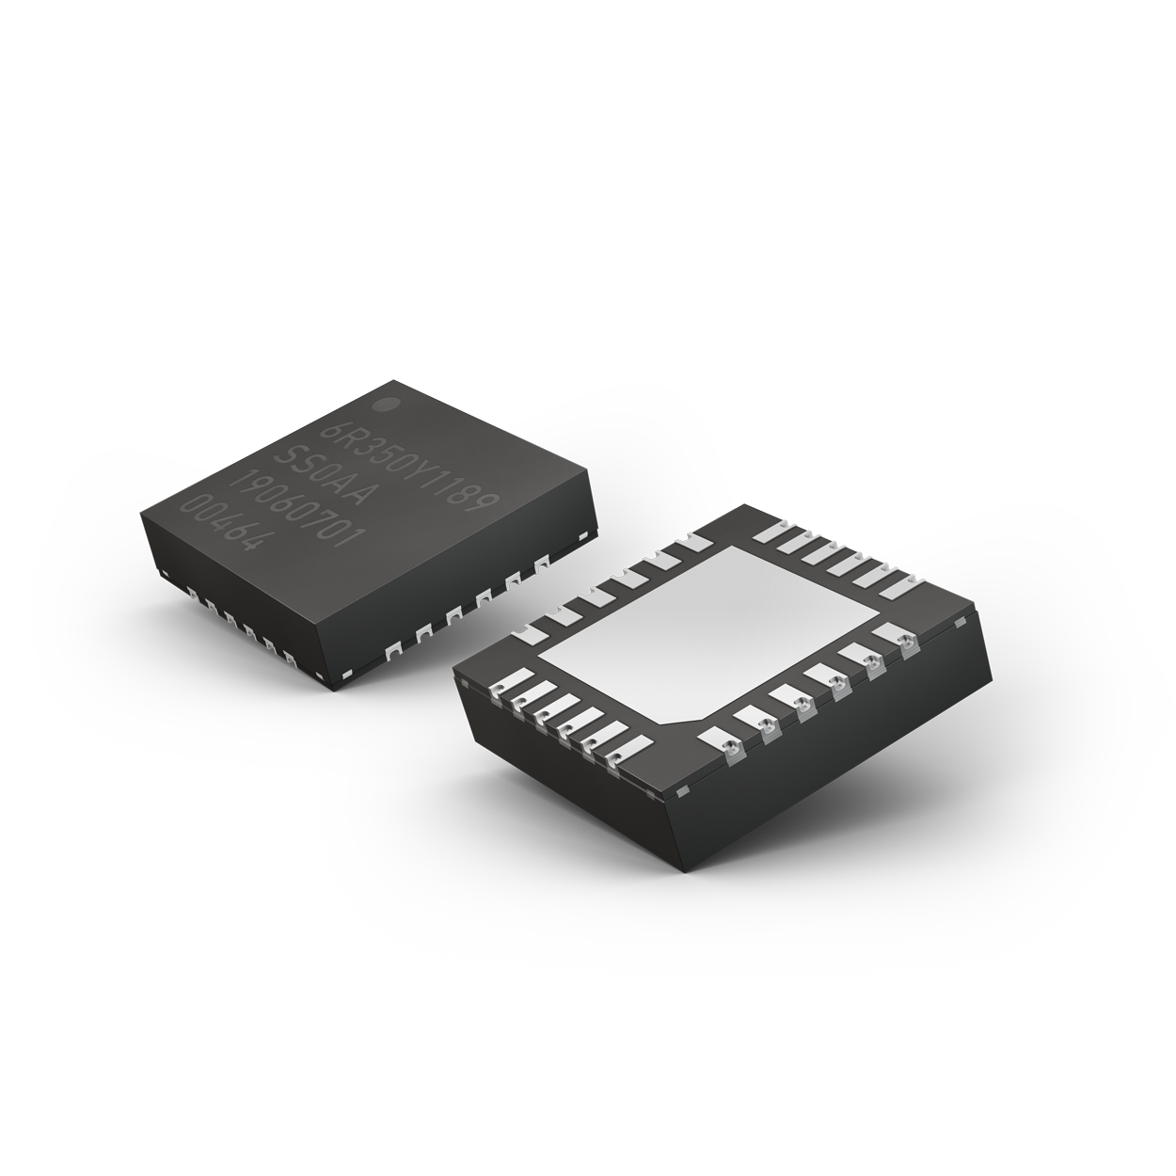The new high-quality and reliable 6-axis Gyro & Accelerometer 6DoF sensor series from Panasonic Industry, also called "6in1 sensor", is available in a wettable flank QFN package. This housing benefits from a special edge that forms a step. The solder creates a reliable connection in the throat of this step. This allows high-quality soldering and thus error-free assembly, which is essential for automotive safety (electronic stability control, ABS brakes, traction control), comfort (navigation, head-up display, driver-assist & comfort), and industrial applications (off-highway industry, AGV, robotics). The highly robust and shock- as well as vibration-resistant.

**Proven and established - for more automotive safety, convenience and control**

A key purpose of the 6DoF sensor is the possibility to detect motion of a vehicle in harsh vibration circumstances, for example when a car suddenly leaves the road. Then the sensor uses data to adjust the torque of motor and the braking force to achieve a safe vehicle status.

The 6DoF sensor has already been successfully implemented to support Radar/Lidar applications, that are relevant for the safety of cars. It detects the motion of the vehicle and Radar/LiDAR system uses the motion data to compare the obstacles detected in previous and current scan.

Also, the 6DoF sensor supports the calculation of the position of a vehicle, if GNSS (Global Navigation Satellite System) signals are blocked, e.g. in tunnels.

Besides these safety-related applications, the 6DoF sensor was successfully implemented in comfort applications like AR-HUD systems. Here the sensor detects the movement of the car and can adjust the position of the AR-HUD beam with AR.markers, in order for the driver to read it in an optimal way. Another comfort-related feature is the possibility to adjust the suspension of the car, using the 6-axis output, that can detect the state of the vehicle and cabin.

Several applications like roadcars, motorcycles and scooters from different manufacturers are already relying on the manifold benefits that are offered by this single sensor.

**Ready for autonomous machinery operation….**

Several inquiries in different states of implementation are ongoing at the moment, to use the 6in1 sensor also in the field of commercial applications. For example, autonomous driving buses can use the 6-axis output to calculate, if the vehicle is on the predefined path. Autonomous forklift applications will benefit from the safety and comfort features that the 6DoF sensor provides - for example to prevent goods from falling off the forklift truck. This also applies for other machinery being on “the doorstep of autonomy” – such as lawn mowers, railway trains or compactors.

**…and heavy duty jobs**

In wood cutters, excavators or agricultural machinery, the sensor system can detect ego-vehicle motion, detect and calculate positions, initiate next operations – and thus contribute to increase precision, productivity and - not least - safety. That is why the 6in1 one sensor currently is becoming more and more subject of industry enquiries, also in those industries.

Ryosuke Toda from Panasonc Industry Europe concludes: “*Customers, who are already using the 6DoF sensor benefit from the features, the system is providing: not only the compact desgin, but also the reliable data generation and supply to connected systems. This enables our customers in various industries to provide safer and more comfortable products – from autonomous driving applications and commercial vehicles to personal mobility concepts or industrial machinery”*

Learn more about the 6DoF inertial sensor series [here.](https://industry.panasonic.eu/components/sensors/6-1)

**About the Panasonic Group**

A global leader in developing innovative technologies and solutions for wide-ranging applications in the consumer electronics, housing, automotive, industry, communications, and energy sectors worldwide, the Panasonic Group switched to an operating company system on April 1, 2022 with Panasonic Holdings Corporation serving as a holding company and eight companies positioned under its umbrella. Founded in 1918, the Group is committed to enhancing the well-being of people and society and conducts its businesses based on founding principles applied to generate new value and offer sustainable solutions for today’s world. The Group reported consolidated net sales of Euro 56.40 billion (7,388.8 billion yen) for the year ended March 31, 2022. Devoted to improving the well-being of people, the Panasonic Group is united in providing superior products and services to help you Live Your Best.   
To learn more about the Panasonic Group, please visit: <https://holdings.panasonic/global/>

**About Panasonic Industry Europe**

Panasonic Industry Europe GmbH is part of the global Panasonic Group and provides automotive and industrial products and services in Europe.

The company’s portfolio covers key electronic components, devices and modules up to complete solutions and production equipment for manufacturing lines across a broad range of industries.

More about Panasonic Industry Europe: <http://industry.panasonic.eu>