Panasonic Industry Europe GmbH
Caroline-Herschel-Strasse 100
85521 Ottobrunn, Germany
http://industry.panasonic.eu

Press contact:
Benno Kirschenhofer
Email:
moritz.cehak@eu.panasonic.com
Phone: ++49-173-6082689
http://industry.panasonic.eu

Precision and versatility in one cordless drill & driver for professional use
Panasonic presents the new EY1DD2 cordless drill & driver for a wide range of applications
Munich, June 2023

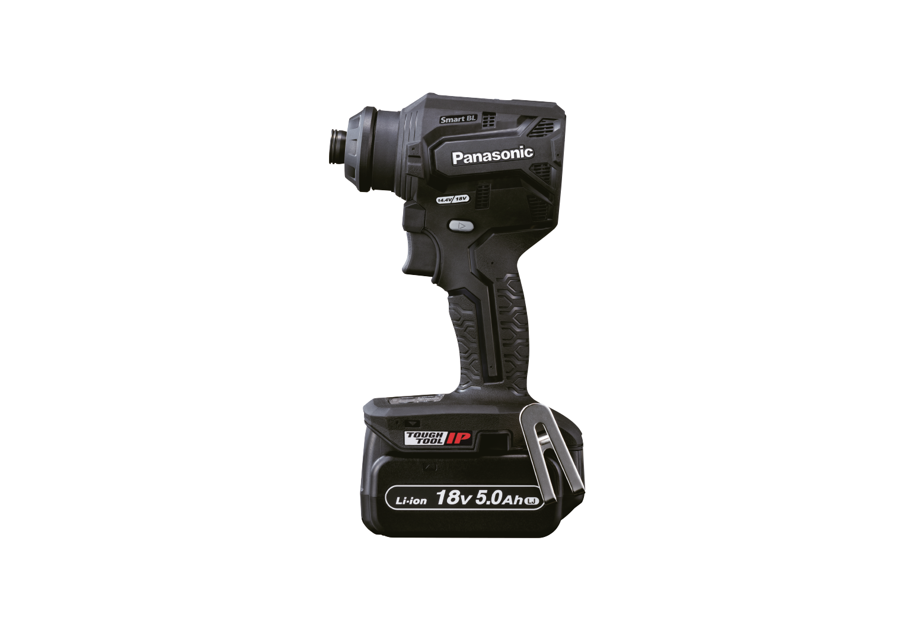
With the EY1DD2, Panasonic Power Tools Europe introduces a versatile cordless drill & driver for demanding operations.
The short body measures only 133mm and with a 5.0Ah battery pack weighs just 1.75kg. But the powertool this light and compact does not lack functionality:
With optional accessories like the ¼ inch Hex Eccentric attachment, that can be mounted in eight positions, precision drilling even in tight corners is made very easy.
Furthermore, a ¼ inch right-angle attachment is available, also connectable to the tools body in eight different positions, to work in tight angle environments. A simple push of bits or drills into the tool is enough to mount them into place. The need to fix the inserts by pulling the quick chuck sleeve is obsolete. And with the keyless drill chuck attachment, straight shank drill bit from 1.5 – 13mm in diameter can also be mounted.

Preset Modes for drilling, driving and tapping

The preset modes of the EY1DD2 allow for a easy and quick adaptation of the power and speed output: “You can choose with just a push of the mode button, how much torque is available for wood or fine metal drilling”, says Kunihiko Nedachi, Head of Power Tools Europe. “Depending on the setting, up to 45Nm of torque are available, and thanks to the new brushless motor and vector control circuit, power and speed are optimized for demanding applications like e.g., heavy-duty serial drilling”.
Also the newly developed electronic clutch enables the drill & driver to provide ideal shut-off clutch torque for precise high-torque fastening. A green LED light indicates when the pre-set shut-off clutch torque has been reached, indicating the desired tightness of the bolt.

Alongside the optional accessories, every cordless drill & driver EY1DD2 comes with a storage space for two 65mm bits in its base, furthermore a belthook and the soft grip texture improve the handling of this versatile power tool.

For further information on the latest member of Panasonic’s Power Tool family, visit the world of Panasonic Power Tools.

About the Panasonic Group
A global leader in developing innovative technologies and solutions for wide-ranging applications in the consumer electronics, housing, automotive, industry, communications, and energy sectors worldwide, the Panasonic Group switched to an operating company system on April 1, 2022 with Panasonic Holdings Corporation serving as a holding company and eight companies positioned under its umbrella. Founded in 1918, the Group is committed to enhancing the well-being of people and society and conducts its businesses based on founding principles applied to generate new value and offer sustainable solutions for today’s world. The Group reported consolidated net sales of Euro 59.40 billion (8,378.9 billion yen) for the year ended March 31, 2023. Devoted to improving the well-being of people, the Panasonic Group is united in providing superior products and services to help you Live Your Best.
To learn more about the Panasonic Group, please visit: https://holdings.panasonic/global/

About Panasonic Industry Europe GmbH
Panasonic Industry Europe GmbH is part of the global Panasonic Industry organization, one of the five major operating companies within Panasonic Holding. Panasonic Industry Europe provides products and services for industrial customers all over Europe.
Panasonic Industry Europe is committed to enabling customers to achieve their goals in a broad range of industrial sectors such as mobility, infrastructure, automation, medical, appliances, smart living, and security. With the know-how of devices and solution technologies, cultivated through a global mindset and over a century of tradition, Panasonic Industry collaborates closely with customers to create a sustainable future.
Panasonic Industry Europe’s broad and diverse product portfolio encompasses key electronic component sectors including electromechanical and passive components, batteries and other energy products, sensors and wireless connectivity modules, thermal management materials and custom solutions, as well as automation devices & solutions.
More about Panasonic Industry Europe: http://industry.panasonic.eu

About the Panasonic Group
Founded in 1918 and today a global leader in developing innovative technologies and solutions for wide-ranging applications in the consumer electronics, housing, automotive, industry, communications, and energy sectors worldwide, the Panasonic Group switched to an operating company system on April 1, 2022, with Panasonic Holdings Corporation serving as a holding company and eight companies positioned under its umbrella.
The Group reported consolidated net sales of Euro 59.40 billion (8,378.9 billion yen) for the year ended March 31, 2023. To learn more about the Panasonic Group, please visit: https://holdings.panasonic/global/

