**Panasonic Industry extends its POSCAP offer with ultimately reliable and compact TLE series**

Guaranteed 2,000 hours at 125°C in compact housing, new TLE series complements Panasonic’s range of Conductive Polymer Tantalum Solid Capacitors.

Munich, November 2022

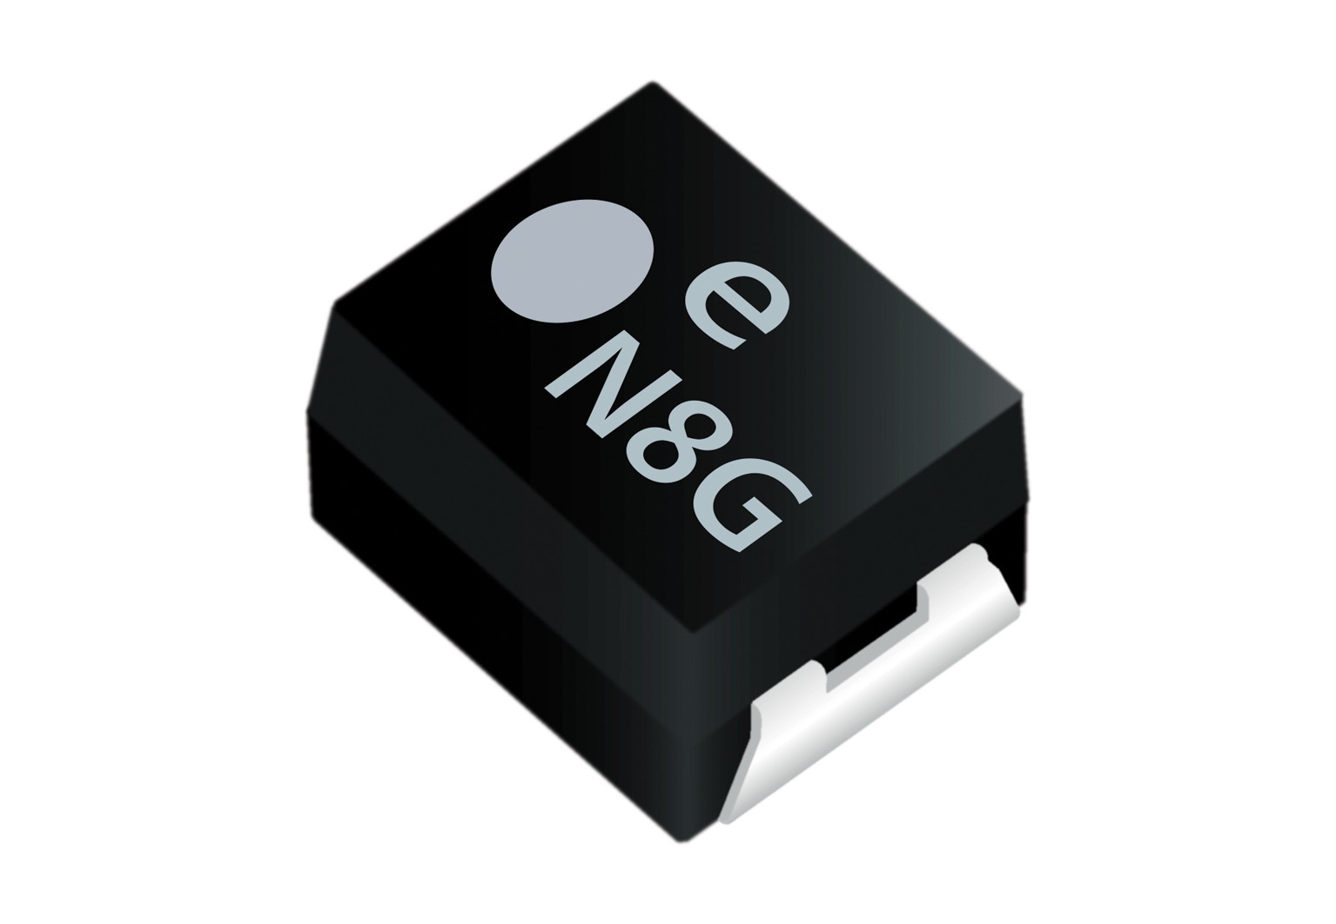POSCAP is Panasonic Industry’s family of Conductive Polymer Tantalum Solid Capacitors. With a high characteristical stability and a low ESR being POSCAP’s typical benefits, the company now introduces its latest POSCAP extension, namely the TLE series that promises an unrivalled reliability, especially in terms of guaranteed heat tolerance.

“5G-readiness is – amongst others – a question of components being reliably heat tolerant”, says Shahrokh Kananizadeh, Product Manager from Panasonic Industry Europe. “The TLE series has proven to safely withstand 125°C for at least 2,000 hours. That renders it the capacitor of choice for next-gen processing units, connectivity applications or 5G-infrastructure devices.”

Accelerators, base stations, servers and high-end processors require capacitors processing high loads in high-temperature environments – and coming in compact dimensions: The TLE series is as small as 3.5 x 2.8 x 1.9mm and thus even suits the power rail around GPUs and CPUs.

“Regarding all the core specs, the TLE series will definitely add a new level of excellence to our POSCAP family now”, summarizes Kananizadeh. “Especially in regards to the emerging importance of modern high performance applications.”

Learn more about the latest member of Panasonic’s POSCAP family [on our web page.](https://industry.panasonic.eu/productfinder?category=Polymer+capacitors&group=Capacitors&lineup=POSCAP&mode=FILTER_MODE&search=&series=TLE)

**About the Panasonic Group**

A global leader in developing innovative technologies and solutions for wide-ranging applications in the consumer electronics, housing, automotive, industry, communications, and energy sectors worldwide, the Panasonic Group switched to an operating company system on April 1, 2022 with Panasonic Holdings Corporation serving as a holding company and eight companies positioned under its umbrella. Founded in 1918, the Group is committed to enhancing the well-being of people and society and conducts its businesses based on founding principles applied to generate new value and offer sustainable solutions for today’s world. The Group reported consolidated net sales of Euro 56.40 billion (7,388.8 billion yen) for the year ended March 31, 2022. Devoted to improving the well-being of people, the Panasonic Group is united in providing superior products and services to help you Live Your Best.   
To learn more about the Panasonic Group, please visit: <https://holdings.panasonic/global/>

**About Panasonic Industry Europe**

Panasonic Industry Europe GmbH is part of the global Panasonic Group and provides automotive and industrial products and services in Europe.

The company’s portfolio covers key electronic components, devices and modules up to complete solutions and production equipment for manufacturing lines across a broad range of industries.

More about Panasonic Industry Europe: <http://industry.panasonic.eu>