Panasonic Industry introduces highly-reliable and durable thin type SMD tactile switches for wide range of miniaturized applications
EVP-BT series switches benefit from very compact design and short travel distance
Munich, August 2022
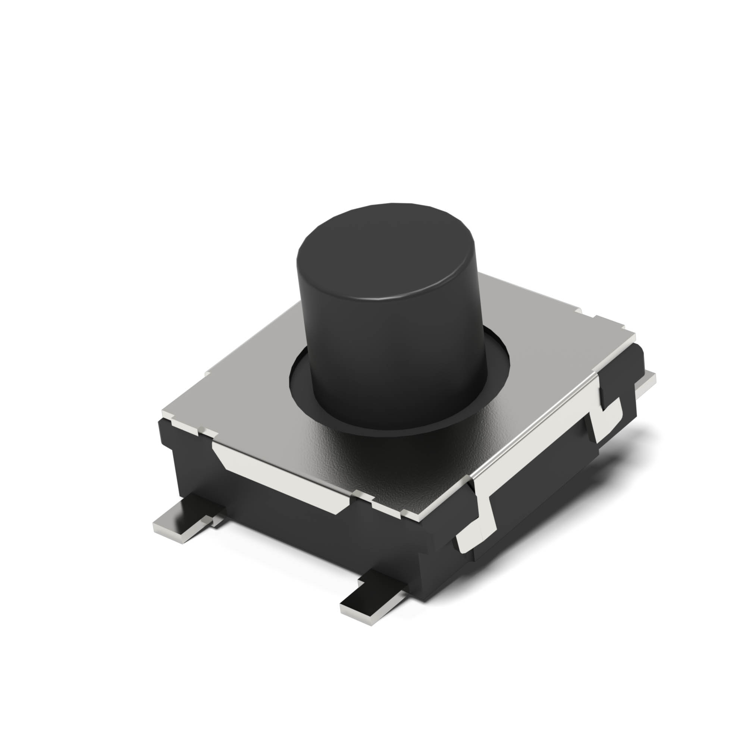
Panasonic Industry is introducing a new series of durable thin type SMD tactile switches for miniaturized apllications requiring a switch with a short travel distance for extremely quick output. The highly compact and robust EVP-BT series switches benefit from a low profile height of only 4.3mm, a sharp tactile feel, a low contact resistance as well as only a small bounce noise.

EVP-BT series switches offer very high reliability with an operating life cycle of up to 2 million. Available with a wide range of variations, e.g. as J-bent and straight terminal types with a total of 28 part numbers, to accomodate many different push forces and vibration specs.

“We are glad that we are now able to offer our proven switches technology with an additional profile height and straight terminals to serve an even wider range of applications - such as smart home, energy, home or medical appliances”, summarizes Markus Lehmann from Panasonic Industry Europe.

Learn more about Panasonic Industry’s new EVP-BT series switches here.

About the Panasonic Group
A global leader in developing innovative technologies and solutions for wide-ranging applications in the consumer electronics, housing, automotive, industry, communications, and energy sectors worldwide, the Panasonic Group switched to an operating company system on April 1, 2022 with Panasonic Holdings Corporation serving as a holding company and eight companies positioned under its umbrella. Founded in 1918, the Group is committed to enhancing the well-being of people and society and conducts its businesses based on founding principles applied to generate new value and offer sustainable solutions for today’s world. The Group reported consolidated net sales of Euro 56.40 billion (7,388.8 billion yen) for the year ended March 31, 2022. Devoted to improving the well-being of people, the Panasonic Group is united in providing superior products and services to help you Live Your Best.
To learn more about the Panasonic Group, please visit: https://holdings.panasonic/global/

About Panasonic Industry Europe
Panasonic Industry Europe GmbH is part of the global Panasonic Group and provides automotive and industrial products and services in Europe.
The company’s portfolio covers key electronic components, devices and modules up to complete solutions and production equipment for manufacturing lines across a broad range of industries.
More about Panasonic Industry Europe: http://industry.panasonic.eu

