The small box for the wall box

Quad power - one eighth power loss: Panasonic Industry releases 40A printed HE-R relay for 3 phase systems with feedback contact. A perfect - and proven - match for EV charging wall boxes.

Munich, SEPTEMBER 2021

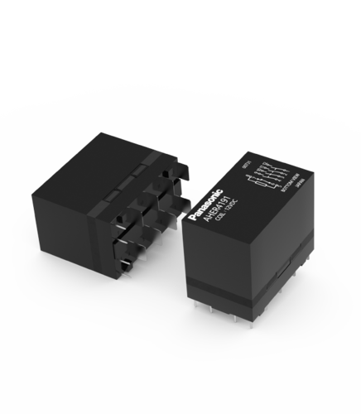EV charging station infrastructure and the spread of efficient domestic wall boxes are more than ever decisive factors for the resounding success of electromobility. Correspondingly, the demand for compact, robust and highly performant components is high. When it comes to switching, there is good news from Panasonic Industry, as the new HE-R relay is the world’s first PCB based relay that can be used as the main switching element in 3 phase systems.  
Being remarkably compact, it contributes to considerable space and cost savings. Each of the 4 NO contacts is able to switch 40A up to an ambient temperature of +85°C - also a result of the sophisticated thermal design and an unique low coil holding power. An optional NC contact as feedback contact can handle low level loads down to 10mA / 5VDC.   
“Because of its outstanding ratio of size, power and robustness, the IEC62955 compliant HE-R relay is the perfect choice for contemporary and demanding AC/DC wall box designs”, claims Panagiotis Venardos from Panasonic Industry Europe. “The advanced technology inside the HE-R enables our customers now to control 3 phase systems directly on the PCB – that might not only be highly interesting for domestic wall boxes, but also for AC or DC charging stations and other fields of application, such as industrial automation or energy harvesting.”

Learn more about the HE-R Relay [here](https://industry.panasonic.eu/products/components/relays/power-relays/he-r-power-relay).

Key features

* - Unique contact arrangement of 4a or 4a1b
* - Compact size : W (35mm) x L (58mm) x H (47mm)
* - Short circuit capability VDE-certified according to IEC 62955, In ≤ 32A
* - Clearance & creepage distance > 8.0mm
* - Coil holding power : 490mW
* - Mirror contact structure according to IEC 60947-4-1
* - Contact gap min. 3.6mm

**About Panasonic**

Panasonic Corporation is a global leader developing innovative technologies and solutions for wide-ranging applications in the consumer electronics, housing, automotive, and B2B sectors. The company, which celebrated its 100th anniversary in 2018, operates 522 subsidiaries and 69 associated companies worldwide and reported consolidated net sales of Euro 54.02 billion (6,698.8 billion yen) for the year ended March 31, 2021. Committed to pursuing new value through collaborative innovation, the company uses its technologies to create a better life and a better world for customers. Learn more about Panasonic: <https://www.panasonic.com/global>

.

**About Panasonic Industry Europe**

Panasonic Industry Europe GmbH is part of the global Panasonic Group and provides automotive and industrial products and services in Europe. As a partner for the industrial sector, Panasonic researches, develops, manufactures and supplies technologies that support the slogan “A Better Life, A Better World”.

The company’s portfolio covers key electronic components, devices and modules up to complete solutions and production equipment for manufacturing lines across a broad range of industries. Panasonic Industry Europe is part of the global company Panasonic Industrial Solutions.

More about Panasonic Industry Europe: <http://industry.panasonic.eu>