20 pins, two rows - and no smarter way for high power connections

Following the market’s high demand for the heat and vibration-proof CF1 board-to-FPC connector, Panasonic Industry now launches the new double-row CF2 version for automotive battery management and lighting systems.

Munich, SEptember 2021

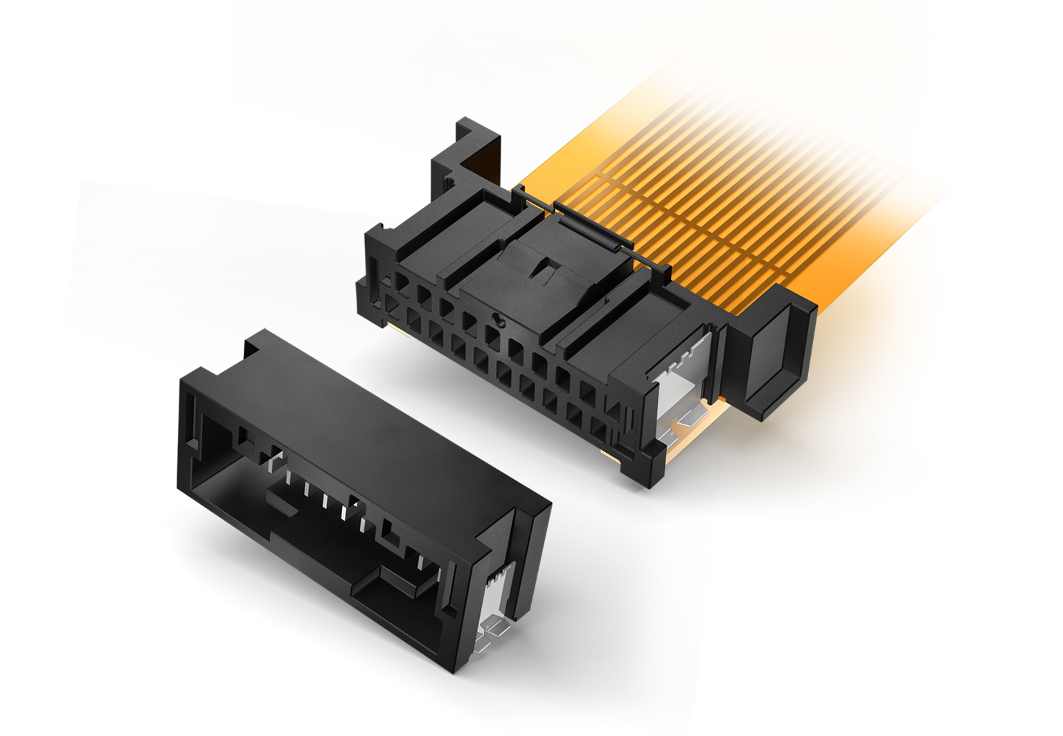For the sake of simplified, time- and cost-efficient assembly, there is no smarter and robust way to connect a PCB with a flexible printed circuit (FPC): Just two parts - a plug and a receptacle - are needed for a reliable, vibration resistant high power connection, making relay wire harnessing sets redundant. These are good news, as the use of daytime running lamps gets more common – let alone the increased usage of battery management systems.   
Following the successful launch of the CF1 connector with 4 to 10 pins in one row, Panasonic Industry now announces the new CF2 type coming with 20 pins in two rows, offering other pin configurations on request.  
“We are glad to serve the automotive market’s demands for clever, reliable and weight-saving connectors now on a wider base with additional pin configurations”, states Carsten Wieber from Panasonic Industry Europe. “Having in mind the electric vehicles’ battery management systems as well as their overall electronic infrastructure are getting more and more sophisticated, we expect the CF2 connector being considered as attractive as the single-row version.”   
For its remarkably compact-sized - CF1/CF2 connector family, Panasonic Industry resorts to a unique metal terminal connection structure, making the direct connection between the FPC and the board possible, overcoming poor assembly workability of wire harnesses.   
Suitable for automotive applications that require shock, vibration and a 125°C heat resistance, the connector's double-sided contact and inertial lock structure prevent incomplete mating and thus guarantee the utmost operational reliability.  
Next to its obvious and highly relevant automotive applications, the CF1/CF2 connectors will also be a modern connector option for non-automotive purposes such as lighting applications, energy storage systems and many more.

Key features:

• For Automotive Applications,125 °C heat resistance  
• ‚Anti-misoperation bridge structure prevents unintended operation of mating lock  
• Contact reliability is preserved by double-sided contact structure  
• Inertia lock construction prevents half-mating  
• Weight and process cost reduction  
  
Learn more on Panasonic Industry’s latest generation of board-to-FPC connectors [here](https://industry.panasonic.eu/products/components/connectors/automotive-connectors/cf1-cf2-board-fpc-connectors)

**About Panasonic**

Panasonic Corporation is a global leader developing innovative technologies and solutions for wide-ranging applications in the consumer electronics, housing, automotive, and B2B sectors. The company, which celebrated its 100th anniversary in 2018, operates 522 subsidiaries and 69 associated companies worldwide and reported consolidated net sales of Euro 54.02 billion (6,698.8 billion yen) for the year ended March 31, 2021. Committed to pursuing new value through collaborative innovation, the company uses its technologies to create a better life and a better world for customers. Learn more about Panasonic: <https://www.panasonic.com/global>

.

**About Panasonic Industry Europe**

Panasonic Industry Europe GmbH is part of the global Panasonic Group and provides automotive and industrial products and services in Europe. As a partner for the industrial sector, Panasonic researches, develops, manufactures and supplies technologies that support the slogan “A Better Life, A Better World”.

The company’s portfolio covers key electronic components, devices and modules up to complete solutions and production equipment for manufacturing lines across a broad range of industries. Panasonic Industry Europe is part of the global company Panasonic Industrial Solutions.

More about Panasonic Industry Europe: <http://industry.panasonic.eu>