Panasonic Industry Europe GmbH
Caroline-Herschel-Strasse 100
85521 Ottobrunn, Germany
http://industry.panasonic.eu

Press contact:
Moritz Cehak
Email:
moritz.cehak@eu.panasonic.com
Phone: +49 89 45354 1228
http://industry.panasonic.eu

Panasonic Industry InfoHub – useful links and downloads for automation devices and solutions

With the all-new InfoHub, Panasonic Industry launched a free online portal that contains programming libraries, documentation, and downloads
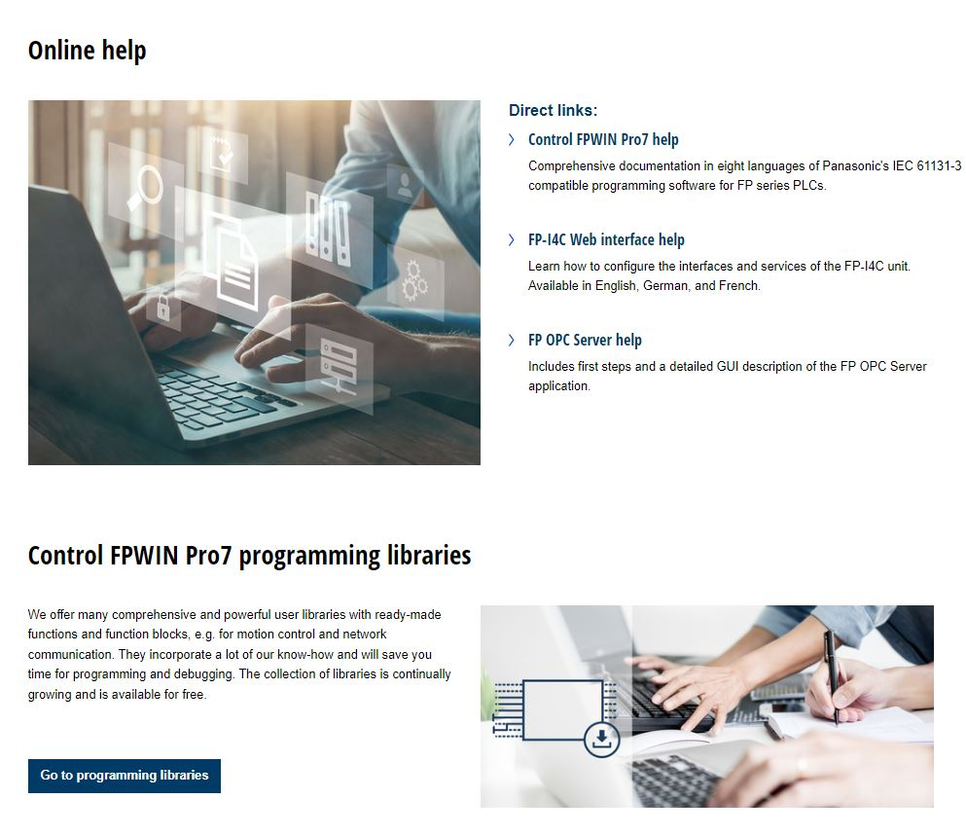
Munich, June 2023

Customers of Panasonic Industry’s industrial motors, HM-series HMIs, Panasonic PLCs, or the Industry 4.0 communicator FP-I4C can now find a comprehensive and state-of-the-art data portal: the Panasonic Industry InfoHub.
The InfoHub not only comprises software files and programming libraries for motion control and network protocols but also user manuals, the latest software versions, and example projects, as well as short instructions and entire help systems.
With this wide-ranging database that is openly accessible, manufacturers, machine builders, and engineers in the factory automation market benefit from the clearly structured and extensive online service.
Online help database
The InfoHub provides detailed information and documentation of Panasonic’s IEC 61131-3 compatible programming software for FP series PLCs, configuration support for interfaces and services of the FP-I4C communication unit, and instructions and descriptions for the FP OPC server software.

Control FPWIN Pro7 programming libraries
The wide range of user libraries for Panasonic Industry’s FP series PLCs include a multitude of options, such as pre-built functions and function blocks, specifically designed for process control, motion control and network communication. These libraries encapsulate our extensive expertise, enabling customers to streamline programming and debugging processes, ultimately saving valuable time.

HMWIN Studio programming examples
The HMWIN Studio software serves as the configuration tool for the entire range of HM series touch terminals. With the programming examples provided by the InfoHub, customers can accelerate the project creation process drastically. These downloadable sample projects offer valuable programming resources, including widgets, dialogs, formulas, trends, and more. Additionally, JavaScript samples and informative content on establishing communication with other devices are available.

By leveraging these resources, customers can optimize their workflow and save significant time. Moreover, the library collection is continuously expanding, and access is free of charge.
To learn more about the InfoHub, please visit InfoHub | Panasonic Industry Europe GmbH
###
About Panasonic Industry Europe GmbH
Panasonic Industry Europe GmbH is part of the global Panasonic Industry organization, one of the five major operating companies within Panasonic Holding. Panasonic Industry Europe provides products and services for industrial customers all over Europe.
Panasonic Industry Europe is committed to enabling customers to achieve their goals in a broad range of industrial sectors such as mobility, infrastructure, automation, medical, appliances, smart living, and security. With the know-how of devices and solution technologies, cultivated through a global mindset and over a century of tradition, Panasonic Industry collaborates closely with customers to create a sustainable future.
Panasonic Industry Europe’s broad and diverse product portfolio encompasses key electronic component sectors including electromechanical and passive components, batteries and other energy products, sensors and wireless connectivity modules, thermal management materials and custom solutions, as well as automation devices & solutions.
More about Panasonic Industry Europe: http://industry.panasonic.eu

About the Panasonic Group
Founded in 1918 and today a global leader in developing innovative technologies and solutions for wide-ranging applications in the consumer electronics, housing, automotive, industry, communications, and energy sectors worldwide, the Panasonic Group switched to an operating company system on April 1, 2023, with Panasonic Holdings Corporation serving as a holding company and eight companies positioned under its umbrella.
The Group reported consolidated net sales of Euro 59.40 billion (8,378.9 billion yen) for the year ended March 31, 2023. To learn more about the Panasonic Group, please visit: https://holdings.panasonic/global/

