Panasonic Industry Europe GmbH
Caroline-Herschel-Strasse 100
85521 Ottobrunn, Germany
http://industry.panasonic.eu

Press contact:
Benno Kirschenhofer
Email:
benno.kirschenhofer@eu.panasonic.com
Phone: ++49-172 2814105
http://industry.panasonic.eu

Panasonic Industry Europe signs official distribution agreement with Özdisan Elektronik
Wide range of Panasonic‘s passive components now available in the Turkish market.
Munich, January 2025
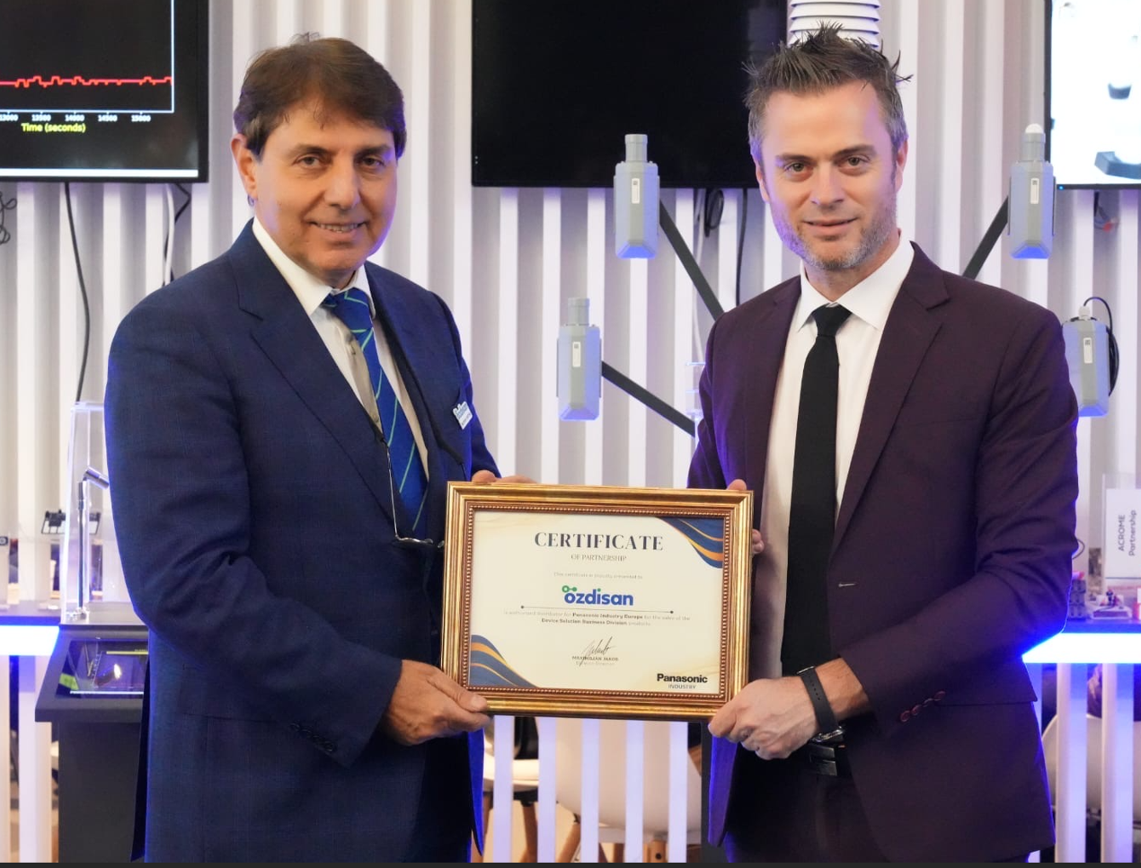
Panasonic Industry Europe GmbH has signed a distribution agreement with Özdisan Elektronik, Turkey's leading electronic components distributor to intensify its business activities in the region.
As part of this agreement, Özdisan Elektronik will serve as the official "High Service Distributor" for Panasonic Industry Europe's products in Turkey, covering areas such as capacitors, inductors, resistors, circuit protection products, sensors, and thermal solutions.
Panasonic Industry Europe is a leading manufacturer in industrial components and solutions, providing reliable and innovative products, particularly in critical sectors such as automotive, industrial automation, consumer electronics, and energy efficiency. Its extensive product range adds value to engineering projects while maintaining the highest standards of quality and durability.
This strong partnership between Özdisan Elektronik and Panasonic Industry Europe will offer customers a rapid supply infrastructure, a wide variety of stock, and technical support advantages. Thanks to Özdisan's "Prototype to Production" approach and a strong regional network, engineers and industrial manufacturers in Turkey will have quick and seamless access to Panasonic's high-quality components.
This important collaboration will not only create significant momentum for the Turkish electronics industry, but also facilitate access to Panasonic's cost-efficient and reliable components in the Turkish market.
Learn more about our new Turkish partners at Özdisan Electronics | Electronic Component Distributor

Caption: Mr Mustafa Yurttaş, General Manager of Özdisan Electronics and Maximilian Jakob, Division Director of Device Solutions at Panasonic Industry Europe
About Panasonic Industry Europe GmbH
Panasonic Industry Europe GmbH is part of the global Panasonic Industry organization, one of the eight major operating companies within Panasonic Holding. Panasonic Industry Europe provides products and services for industrial customers all over Europe.
Panasonic Industry Europe is committed to enabling customers to achieve their goals in a broad range of industrial sectors such as mobility, infrastructure, automation, medical, appliances, smart living, and security. With the know-how of devices and solution technologies, cultivated through a global mindset and over a century of tradition, Panasonic Industry collaborates closely with customers to create a sustainable future.
Panasonic Industry Europe’s broad and diverse product portfolio encompasses key electronic component sectors including electromechanical and passive components, batteries and other energy products, sensors and wireless connectivity modules, thermal management materials and custom solutions, as well as automation devices & solutions.
More about Panasonic Industry Europe: http://industry.panasonic.eu
About the Panasonic Group
Founded in 1918 and today a global leader in developing innovative technologies and solutions for wide-ranging applications in the consumer electronics, housing, automotive, industry, communications, and energy sectors worldwide, the Panasonic Group switched to an operating company system on April 1, 2022, with Panasonic Holdings Corporation serving as a holding company and eight companies positioned under its umbrella.
The Group reported consolidated net sales of Euro 54.12 billion (8,496.4 billion yen) for the year ended March 31, 2024. To learn more about the Panasonic Group, please visit: https://holdings.panasonic/global/

