Panasonic Industry Europe GmbH

Caroline-Herschel-Strasse 100

85521 Ottobrunn, Germany

[http://industry.panasonic.eu](http://industry.panasonic.eu/)

Press contact:

Benno Kirschenhofer

Email:

[benno.kirschenhofer@eu.panasonic.com](mailto:benno.kirschenhofer@eu.panasonic.com)

Phone: ++49-172 2814105

[http://industry.panasonic.eu](http://industry.panasonic.eu/)

**Unparalleled accuracy and longevity: Panasonic Industry presents brand new ultra-compact Air Quality Sensor**  
Next level monitoring precision of particulate matter, temperature, humidity, and total volatile organic compounds (TVOCs)

Munich, November 2024

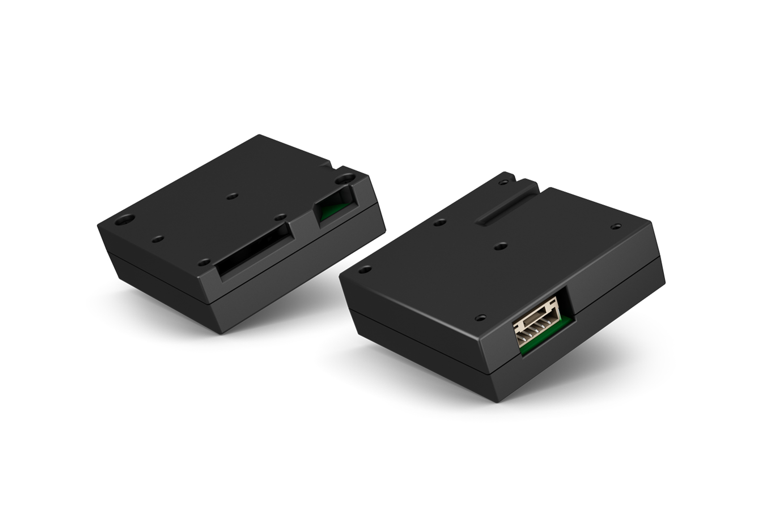With the release of the new SN-GCQB1 Laser Type Air Quality Sensor, Panasonic Industry marks a significant leap forward in air quality monitoring technology, setting new standards for accuracy, compactness, and longevity for a wide field of relevant installation designs. Engineered to provide precise measurements of particulate matter, temperature, humidity, and total volatile organic compounds (TVOCs), this sensor might re-define the perception and management of air quality in different environments.

**Unmatched Precision and Compact Design**  
One of the standout features of Panasonic’s SN-GCQB1 is its remarkable precision coupled with an ultra-compact housing, making it one of the smallest on the market. With optimized air pathway structure to minimize dust accumulation - and thus to protect electronic components - this sensor ensures unparalleled accuracy even in the most challenging surroundings.

**Comprehensive Air Quality Monitoring**Designed to detect particulate matter in three key classes - PM1.0, PM2.5, and PM10 - this sensor utilizes a high-precision optical sensor and a unique optical design for enhanced small particle detection. Moreover, its auto-calibration feature guarantees long-term detection accuracy, providing reliable data over extended periods.

**Enhanced Features for Versatile Applications**In addition to particulate matter detection, the SN-GCQB1 monitors temperature, humidity, and total volatile organic compounds (TVOCs). Equipped with a special resin outer shell, it is protected against electromagnetic waves, ensuring improved long-term drift performance, measurement stability, and response time.

**Longevity and Reliability**With a projected lifetime exceeding 10 years, this sensor offers unmatched longevity, making it an ideal choice for various applications such as factory clean air management, environmental sensing, HVAC installations, room air conditioners, air purifiers, and more.

**Setting New Standards**By providing accurate data on air quality parameters, including estimated carbon dioxide concentration calculated by TVOCs and IAQ levels according to UBA standards (German Environment Agency), this latest air quality monitoring innovation from Panasonic will offer an unrivalled level of sensor precision, reliability, and versatility for a vast field of relevant product designs.

For more information about the new SN-GCQB1 Laser Type Air Quality Sensor and its applications, please visit [Air quality sensor](https://industry.panasonic.eu/products/components/sensors/air-quality-sensor)

**About Panasonic Industry Europe GmbH**

Panasonic Industry Europe GmbH is part of the global Panasonic Industry organization, one of the five major operating companies within Panasonic Holding. Panasonic Industry Europe provides products and services for industrial customers all over Europe.   
Panasonic Industry Europe is committed to enabling customers to achieve their goals in a broad range of industrial sectors such as mobility, infrastructure, automation, medical, appliances, smart living, and security. With the know-how of devices and solution technologies, cultivated through a global mindset and over a century of tradition, Panasonic Industry collaborates closely with customers to create a sustainable future.

Panasonic Industry Europe’s broad and diverse product portfolio encompasses key electronic component sectors including electromechanical and passive components, batteries and other energy products, sensors and wireless connectivity modules, thermal management materials and custom solutions, as well as automation devices & solutions.

More about Panasonic Industry Europe: <http://industry.panasonic.eu>

**About the Panasonic Group**

Founded in 1918 and today a global leader in developing innovative technologies and solutions for wide-ranging applications in the consumer electronics, housing, automotive, industry, communications, and energy sectors worldwide, the Panasonic Group switched to an operating company system on April 1, 2022, with Panasonic Holdings Corporation serving as a holding company and eight companies positioned under its umbrella.

The Group reported consolidated net sales of Euro 59.40 billion (8,378.9 billion yen) for the year ended March 31, 2023. To learn more about the Panasonic Group, please visit: <https://holdings.panasonic/global/>