Panasonic Industry Europe GmbH

Caroline-Herschel-Strasse 100

85521 Ottobrunn, Germany

[http://industry.panasonic.eu](http://industry.panasonic.eu/)

Press contact:

Moritz Cehak

Email:

[[moritz.cehak@eu.panasonic.com](mailto:benno.kirschenhofer@eu.panasonic.com)](mailto:moritz.cehak@eu.panasonic.com)  
Phone: +49 89 45354 1228

[http://industry.panasonic.eu](http://industry.panasonic.eu/)

**Motion sensing for street lighting and aisle applications made easy**

Panasonic Industry introduces the new PaPIRs Ultra Wide and Long Distance Detection Type

Munich, AUGUST 2023

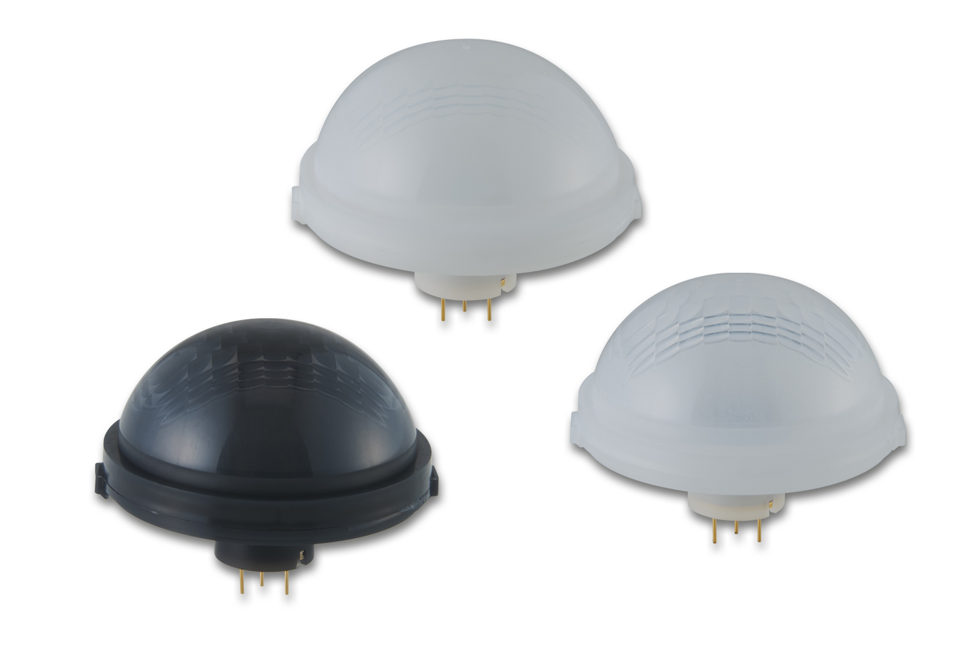The world's most compact long-range passive infrared motion sensor from Panasonic Industry (PaPIRs) has recently been introduced: The new Ultra Wide and Long Distance Detection Type for installation heights of up to 15 m and a maximum field of view (FOV) of 91.6° x 45.4° sets new standards in terms of lens size, detection area and integration options.

For miniaturizing motion detectors where PIR sensors with small but extremely sensitive pyroelectric sensor elements must be used, PaPIRs Motion Sensors set their own unparalleled standards.

With its incredibly small lens diameter of only 32.6mm and a detection area of 30.9 meters by 12.6 meters at an installation height of 15 meters, the new Ultra Wide and Long Distance Detection Type is the most compact long-range sensor available on the market, making it ideal for high-ceiling installations.

The configuration of the 188 detection zones enables exceptional detection of radial movement and minimizes blind spots, ensuring that no motion goes unnoticed.

By precisely identifying human presence, the sensor provides accurate data for lighting control, resulting in optimal illumination and significant energy savings.

In addition to its exceptional performance, the Ultra-Wide and Long-Distance Detection type is easy to install and integrate into existing lighting systems. It features the following user-friendly interfaces:

* Digital (open-drain output)
* Analog (op-amp output)

and supports seamless integration with various lighting control protocols. The robust and UV-stabilized lens ensures durability, making it suitable for both indoor and outdoor environments.

"We are thrilled to introduce the new Ultra Wide and Long Distance Detection sensor to the market," says Robert Spiegler, Lead Product Manager, Solution Business at Panasonic Industry Europe. "This new PaPIRs sensor showcases our commitment to delivering innovative lighting control components that enhance efficiency, and sustainability. We are confident it will streamline sensor integration in aisle and street lighting applications, while providing our customers with unmatched levels of performance, reliability, and speed to market"  
  
To learn more about the new ultra-wide and long-distance PaPIRs sensor, please visit [Passive Infrared Motion Sensors - PaPIRs | Panasonic Industry Europe GmbH](https://industry.panasonic.eu/products/components/sensors/passive-infrared-motion-sensors-papirs/ultra-wide-and-long-distance-type)  
  
**###**

**About Panasonic Industry Europe GmbH**

Panasonic Industry Europe GmbH is part of the global Panasonic Industry organization, one of the five major operating companies within Panasonic Holding. Panasonic Industry Europe provides products and services for industrial customers all over Europe.   
   
Panasonic Industry Europe is committed to enabling customers to achieve their goals in a broad range of industrial sectors such as mobility, infrastructure, automation, medical, appliances, smart living, and security. With the know-how of devices and solution technologies, cultivated through a global mindset and over a century of tradition, Panasonic Industry collaborates closely with customers to create a sustainable future.

Panasonic Industry Europe’s broad and diverse product portfolio encompasses key electronic component sectors including electromechanical and passive components, batteries and other energy products, sensors and wireless connectivity modules, thermal management materials and custom solutions, as well as automation devices & solutions.

More about Panasonic Industry Europe: [http://industry.panasonic.eu](http://industry.panasonic.eu/)

**About the Panasonic Group**

Founded in 1918 and today a global leader in developing innovative technologies and solutions for wide-ranging applications in the consumer electronics, housing, automotive, industry, communications, and energy sectors worldwide, the Panasonic Group switched to an operating company system on April 1, 2023, with Panasonic Holdings Corporation serving as a holding company and eight companies positioned under its umbrella.    
   
The Group reported consolidated net sales of Euro 59.40 billion (8,378.9 billion yen) for the year ended March 31, 2023. To learn more about the Panasonic Group, please visit: [https://holdings.panasonic/global/](https://holdings.panasonic/global/" \t "_blank)