Pinpoint detection with the HG-F laser distance sensor from Panasonic Industry

Up to 3 meters of detection range, a robust aluminum casing and easy setup are just the some of the features of the new HG-F laser distance sensor
Munich, MARCH 2023
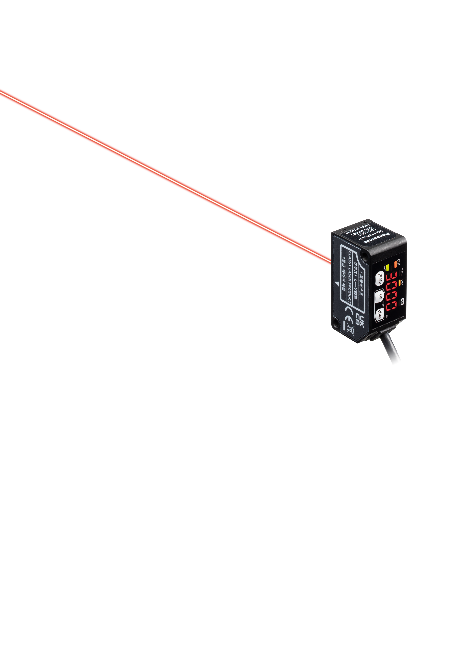
Panasonic Industry presents the new laser distance sensor HG-F, that can detect reliably at distances of up to 3m using ToF (Time of Flight) technology. This means that the sensor can also be installed at some distance from the object to be measured so that employees or the movement radius of cobots or robot arms can operate freely.
The long range of the HG-F also ensures freedom of design: installation at a distance also enables the measurement of large workpieces or products of different heights on a line.
As a laser sensor, the HG-F uses ToF technology and falls into laser class 1. The advantage of this laser class is on the one hand that no special protective devices are necessary. On the other hand, the visible laser beam allows the measuring position to be recognised at first glance, which is helpful when setting up the sensor. In addition, the HG-F has a special installation mode that makes commissioning particularly easy by amplifying the light intensity.
Another advantage of laser measurement is the fact that the laser beam has a narrow passage to the workpiece. This makes the HG-F ideal for applications where there is little space available for optical measurement.

Compact and robust sensing solution
The HG-F was designed in a compact, lightweight and high-strength aluminum diecast case, that only measures 20 x 44 x 25 mm. So, it is suited for operation in demanding environments with limited space. And due to the fact, that the beam spot is smaller compared to conventional adjustable range distance sensors, the HG-F sensor can be installed for detection through a narrow gap in the machine.
Another feature for an easy installation process is the digital display on the sensor. Alongside the three buttons, the desired measuring distance can be numerically set on the sensor, and the display provides immediate feedback of the desired clearance.
To learn more about the HG-F1 sensor, please visit
Measurement sensors | Panasonic Industry Europe GmbH

###

About Panasonic Industry Europe GmbH
Panasonic Industry Europe GmbH is part of the global Panasonic Industry organization, one of the five major operating companies within Panasonic Holding. Panasonic Industry Europe provides products and services for industrial customers all over Europe.
Panasonic Industry Europe is committed to enabling customers achieve their goals in a broad range of industrial sectors such as mobility, infrastructure, automation, medical, appliances, smart living, and security. With the know-how of devices and solution technologies, cultivated through a global mindset and over a century of tradition, Panasonic Industry collaborates closely with customers to create a sustainable future.
Panasonic Industry Europe’s broad and diverse product portfolio encompasses key electronic component sectors including electromechanical and passive components, batteries and other energy products, sensors and wireless connectivity modules, thermal management materials and custom solutions, as well as automation devices & solutions.
More about Panasonic Industry Europe: http://industry.panasonic.eu

About the Panasonic Group
A global leader in developing innovative technologies and solutions for wide-ranging applications in the consumer electronics, housing, automotive, industry, communications, and energy sectors worldwide, the Panasonic Group switched to an operating company system on April 1, 2022, with Panasonic Holdings Corporation serving as a holding company and eight companies positioned under its umbrella.
Founded in 1918, the Group is committed to enhancing the well-being of people and society and conducts its businesses based on founding principles applied to generate new value and offer sustainable solutions for today’s world.
The Group reported consolidated net sales of Euro 56.40 billion (7,388.8 billion yen) for the year ended March 31, 2022. Devoted to improving the well-being of people, the Panasonic Group is united in providing superior products and services to help you Live Your Best.
To learn more about the Panasonic Group, please visit: https://holdings.panasonic/global/

