E-bikes since 1979 – from now on closer to Europe
Panasonic Cycle Technology announces first European sales office in Ottobrunn near Munich
Munich, DECEMBER 2020
It has been long before electrically assisted cycling became a mass (and growth) market, when Panasonic presented its first e-bike 1979 in Japan. Bicycles always enjoyed a particular attention within the global corporation - company founder Konosuke Matsushita worked in a bicycle store in his youth -and have been part of the product range since the 1950s.

Also nowadays, Panasonic Cycle Technology is setting trends in the e-bike market - not only with battery technology, but also with the powerful motors of the GX series.

Although Panasonic has been active on the European market for twenty years now, the sales structures for two-wheelers have been centrally governed by Japan so far. Now, with the new sales office in the outskirts of Munich, Bavaria, Panasonic is now focusing close customer relations and short distances in the European e-bikes markets.

Accommodated in the premises of Panasonic Industry Europe GmbH with its 600 employees, The team around Andreas Böxler and Peter Obermeier plans to make the big brand’s innovative technology more visible - and perceived as an excellent choice for the continent’s roads and trails.

Learn more: https://eu.industrial.panasonic.com/sites/default/pidseu/files/downloads/files/100719_panasonic_ebike_broschure_en.pdf

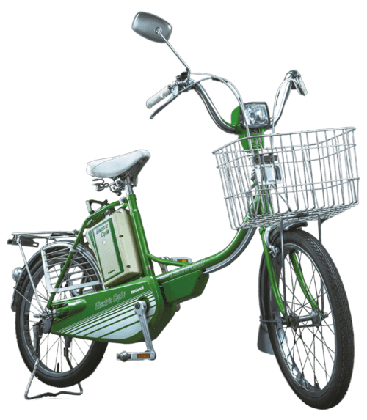 | Origin of a mass phenomenon: Panasonic’s first e-bike from 1979
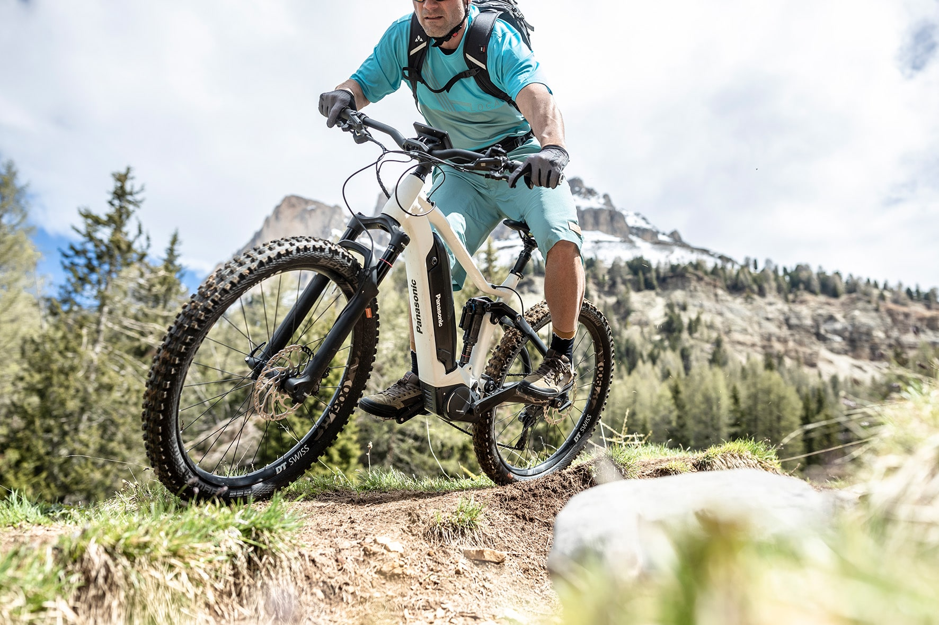 | A contemporary standard of power and torque: The range of Panasonic’s GX motors
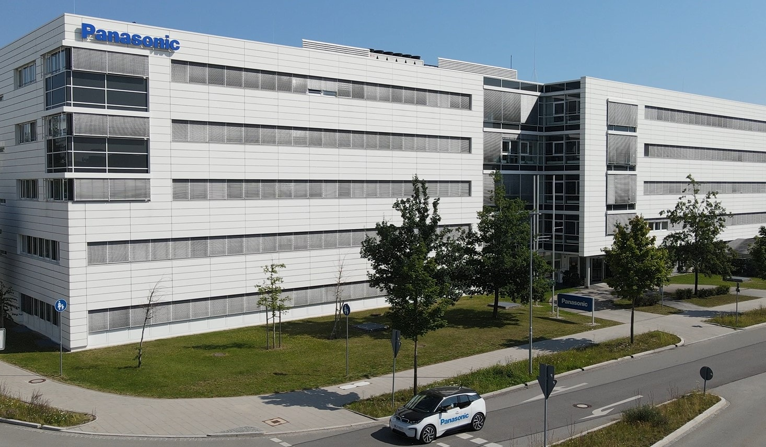 | In the heart of Europe: Panasonic Cycle Technology is accommodated under the roof of Panasonic Industry Europe in Ottobrunn south of Munich
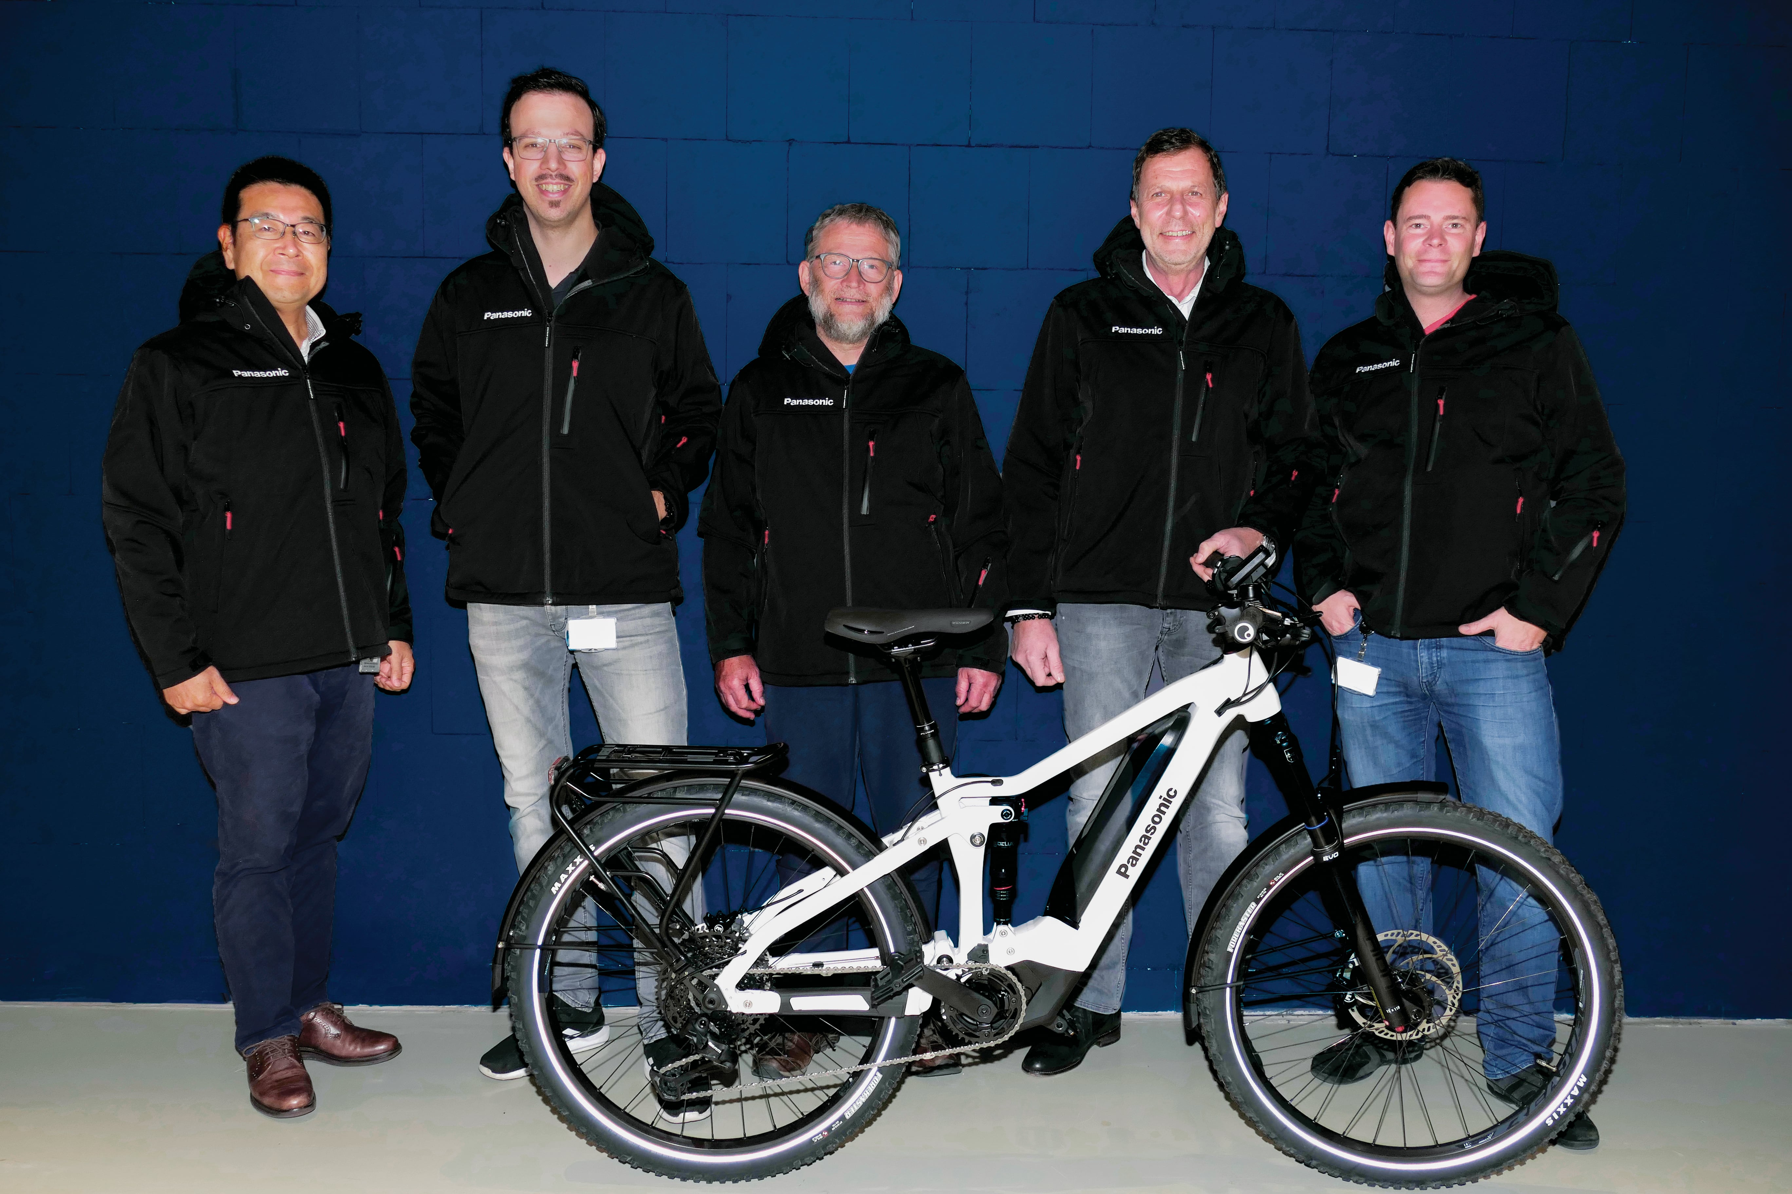 | Taking Panasonic Cycle Technology to a new level of attention: The dedicated Ottobrunn sales team.
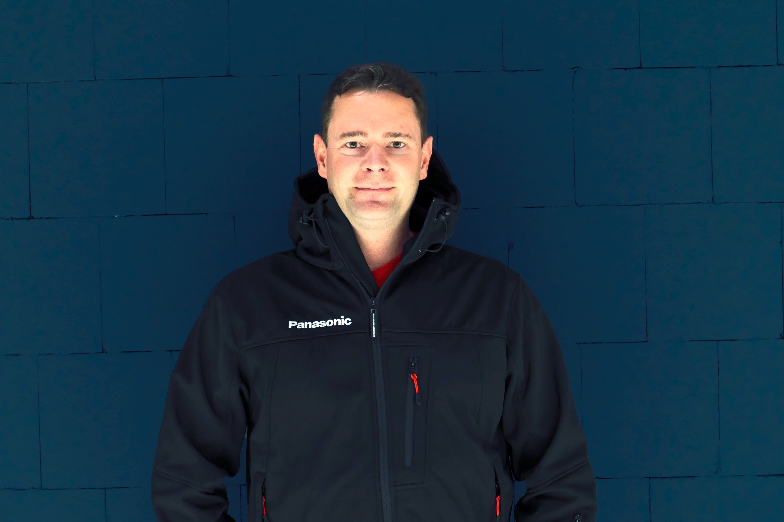 | Andreas Böxler: Account Manager, Consulting and Service Management for OEM partners.  With more than 20 years of experience in e-bike technology and sales, he joined Panasonic in 2014.
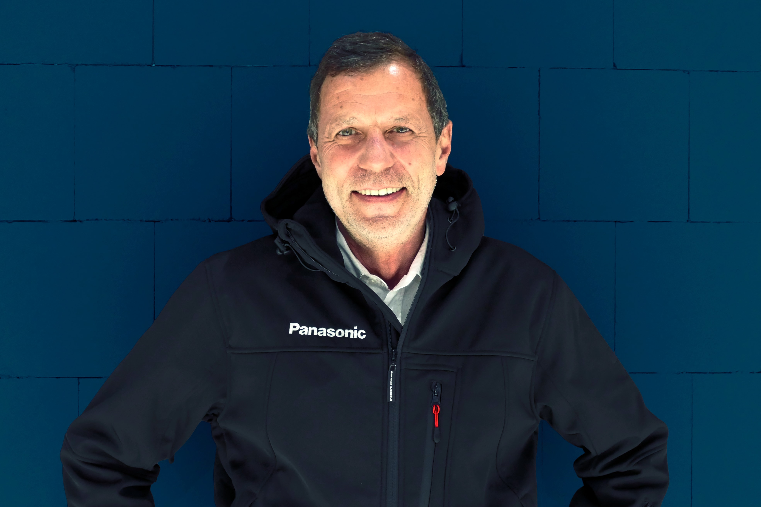 | Peter Obermeier: Senior Business Development Manager, also with a distinct “bicycle history”: before joining Panasonic. Formerly, he worked for UNIVEGA/Derby and most recently for BIONX.

About Panasonic
Panasonic Corporation is a global leader developing innovative technologies and solutions for wide-ranging applications in the consumer electronics, housing, automotive, and B2B sectors. The company, which celebrated its 100th anniversary in 2018, operates 528 subsidiaries and 72 associated companies worldwide and reported consolidated net sales of 61.9 billion Euro (7.49 trillion yen) for the year ended March 31, 2020. Committed to pursuing new value through collaborative innovation, the company uses its technologies to create a better life and a better world for customers.
To learn more about Panasonic: http://www.panasonic.com/global

About Panasonic Industry Europe
Panasonic Industry Europe GmbH is part of the global Panasonic Group and provides automotive and industrial products and services in Europe. As a partner for the industrial sector, Panasonic researches, develops, manufactures and supplies technologies that support the slogan “A Better Life, A Better World”.
The company’s portfolio covers key electronic components, devices and modules up to complete solutions and production equipment for manufacturing lines across a broad range of industries. Panasonic Industry Europe is part of the global company Panasonic Industrial Solutions.
More about Panasonic Industry Europe: http://industry.panasonic.eu

