**Plug-in 5G data stability**

Panasonic Industry presents its simplified and stable Board to FPC Connector for 5G Millimeter-wave Antenna Modules in modern communication devices

Munich, DECEMBER 2020

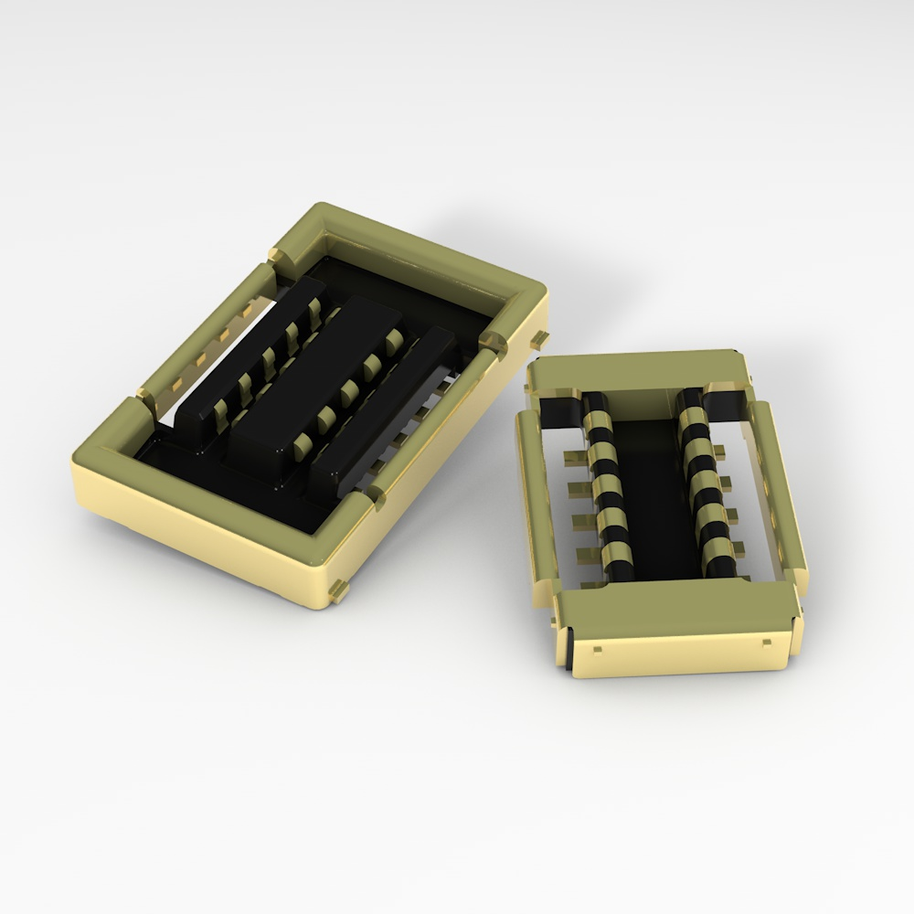5G – the current framework for mobile communication reality means nothing less than an entirely new dimension in capacity, speed and simultaneity of daily data communication – especially within the defined frequency range 2 (FR2) using the millimeter-wave spectrum (28 GHz band). This is boosting the necessity for device technology being able to reliably handle a corresponding extent of data transmission.

To ensure devices like smartphones, routers and many others meeting those data transmission stability requirements, Panasonic Industry now offers a specific Board to FPC (Flexible Printed Circuit) Connector for 5G, connecting the antenna module with the main board and thus contributing to an immaculate data flow for applications operating in the range of millimeter-waves.  
“The connector fully meets what we expect from technology being compatible with the potentials of 5G”, points out Carsten Wieber from Panasonic Industry. “It is constructively robust, per se ready for a large amount of simultaneous high frequency signals, shields signal interferences and allows simplified circuit designs.”   
The FPC connector replaces conventional coaxial connectors usually necessary for the extensive mm-wave antenna infrastructure – and thus renders additional cables, components and assembly efforts as redundant.  
Noise prevention and hence communication stability is achieved by the means of a metal shielding structure, covering the connector’s socket and the header's outer part, resulting in optimized EMI/EMS characteristics   
This very metal shielding - and Panasonic Industry’s unique tough contact structure ensure the connector being flawlessly robust and resistant to shocks, vibrations and all other impacts that prevail for most of modern IoT or portable communication devices.  
Learn more on the 5G Board to FPC Connector here:

<https://industry.panasonic.eu/components/connectors/industrial-connectors/rf35-board-fpc-connector-5g-hf-applications>

**About Panasonic**

Panasonic Corporation is a global leader developing innovative technologies and solutions for wide-ranging applications in the consumer electronics, housing, automotive, and B2B sectors. The company, which celebrated its 100th anniversary in 2018, operates 528 subsidiaries and 72 associated companies worldwide and reported consolidated net sales of 61.9 billion Euro (7.49 trillion yen) for the year ended March 31, 2020. Committed to pursuing new value through collaborative innovation, the company uses its technologies to create a better life and a better world for customers.   
To learn more about Panasonic: <http://www.panasonic.com/global>

**About Panasonic Industry Europe**

Panasonic Industry Europe GmbH is part of the global Panasonic Group and provides automotive and industrial products and services in Europe. As a partner for the industrial sector, Panasonic researches, develops, manufactures and supplies technologies that support the slogan “A Better Life, A Better World”.

The company’s portfolio covers key electronic components, devices and modules up to complete solutions and production equipment for manufacturing lines across a broad range of industries. Panasonic Industry Europe is part of the global company Panasonic Industrial Solutions.

More about Panasonic Industry Europe: <http://industry.panasonic.eu>