**Panasonic Industry Europe releases ZF series, high temperature and high current Conductive Polymer Hybrid Aluminum Electrolytic Capacitors**

New low ESR and high ripple current capacitor series is fully AEC-Q200 compliant

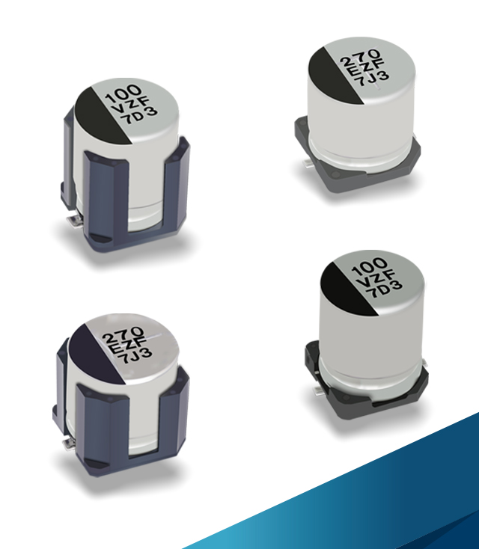Munich, April 2020

Panasonic Industry Europe has recently introduced the new surface-mount type ZF series of Conductive Polymer Hybrid Aluminum Electrolytic Capacitors. Being able to endure high temperatures of 150°C for up to 1.000 hours, the new capacitors benefit from a high withstand voltage of 25V to 63V and a low leakage current of (0.01 CV or 3µA). The nominal capacitance range is 33µF to 270µF.

The AEC-Q200 qualification of ZF series products ensures optimal quality and reliability and makes the parts ideal for demanding applications like AC/DC converters, DC link capacitor for servo motor inverter power supply in robotics, Actuator for Exhaust System, DC/DC converters in automotive transmission control units, DC link capacitor for motor inverter power supply in oil/water pumps or EPS units.

Vibration-proof variants of the ZF series capacitors are available for the entire voltage and capacitance range. The components are fully RoHS compliant.

Further information can be found [here.](https://eu.industrial.panasonic.com/products/capacitors/polymer-capacitors/polymer-hybrid-aluminium-electrolytic-capacitor-0/series/zf-high-temp-reflow/ABA0160?reset=1)

__________

**About Panasonic**

Panasonic Corporation is a worldwide leader in the development of diverse electronics technologies and solutions for customers in the consumer electronics, housing, automotive, and B2B businesses. The company, which celebrated its 100th anniversary in 2018, has expanded globally and now operates 582 subsidiaries and 87 associated companies worldwide, recording consolidated net sales of US$72.10 billion for the year ended March 31, 2019. Committed to pursuing new value through innovation across divisional lines, the company uses its technologies to create a better life and a better world for its customers.

To learn more about Panasonic: <http://www.panasonic.com/global>

**About Panasonic Industry Europe**

Panasonic Industry Europe GmbH is part of the global Panasonic Group and provides automotive and industrial products and services in Europe. As a partner for the industrial sector, Panasonic researches, develops, manufactures and supplies technologies that support the slogan “A Better Life, A Better World”.

The company’s portfolio covers key electronic components, devices and modules up to complete solutions and production equipment for manufacturing lines across a broad range of industries. Panasonic Industry Europe is part of the global company Panasonic Industrial Solutions.

More about Panasonic Industry Europe: <http://industry.panasonic.eu>